PISHPEK
Military barracks
42.87272, 74.59794
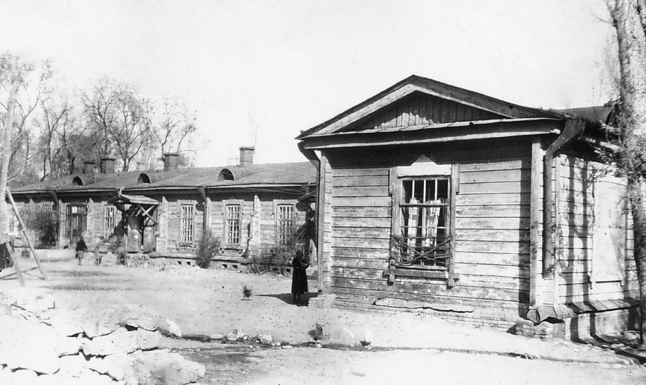
Военные казармы
ENGLISH Military barracks
﻿ Military barracks 1878 Demolished in 2012 One of the first buildings of Pishpek, barracks for the local military command, was located on the southwestern outskirts of the city. There was also an area for military formations and exercises, and an infirmary. The military team consisted of 150 people with a military commander, who is also the commandant of the city, and two junior officers. The military team was staffed partly by local residents,
Source: https://bimap.su/description/pishpek/56_Kazarma1878.txt · BIMAP
Фотографии и материалы принадлежат их авторам; лицензия не указана

FRUNZE
Military town
42.87272, 74.59794
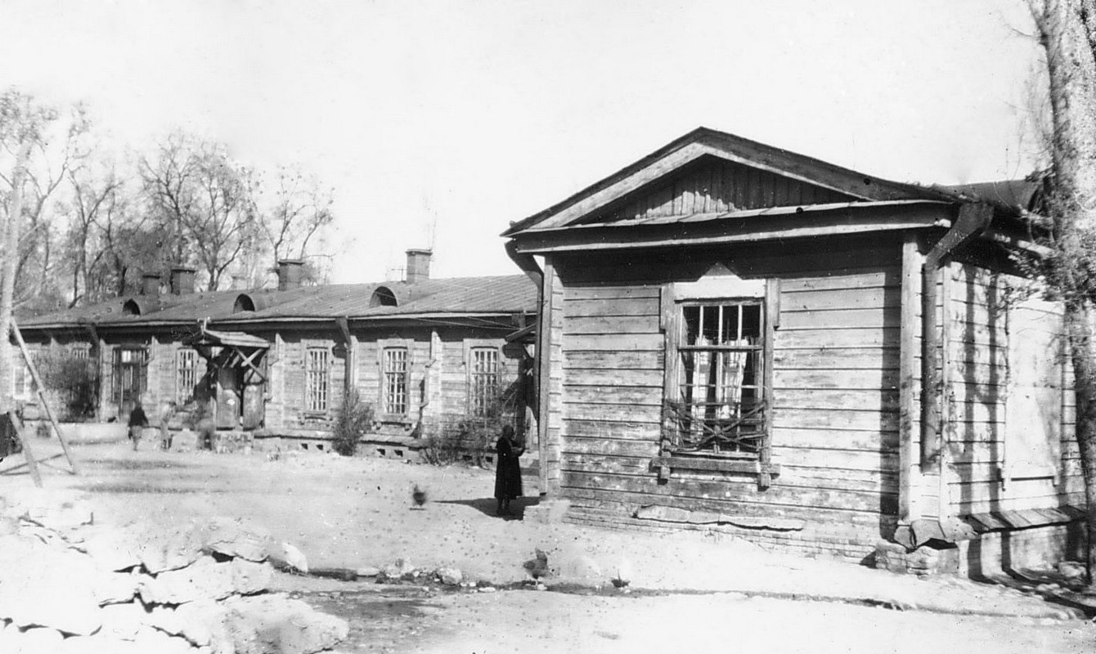
Военный городок
ENGLISH Military town
﻿ Military town Military barracks, 40th. The oldest wooden, stone and adobe buildings in the city. Initially, Togolok Moldo street was called Kazarmennaya, Logvinenko street - Bolnichnaya, Bokonbaev street - Lagernaya, because almost along its entire length from Frunze-Sudeiskaya street to the southern outskirts this territory of the city was occupied by military buildings - barracks, an infirmary, military squares, training grounds and camps. Du
Source: https://bimap.su/description/frunze/130_Kazarma1878.txt · BIMAP
Фотографии и материалы принадлежат их авторам; лицензия не указана

BISHKEK
No information has been found for this period yet
42.87272, 74.59794

Фотография пока не добавлена
ENGLISH
No information has been found for this period yet.

