PISHPEK
No information has been found for this period yet
42.86184, 74.58660

Фотография пока не добавлена
ENGLISH
No information has been found for this period yet.

FRUNZE
Plant named after V.I. Lenin
42.86184, 74.58660
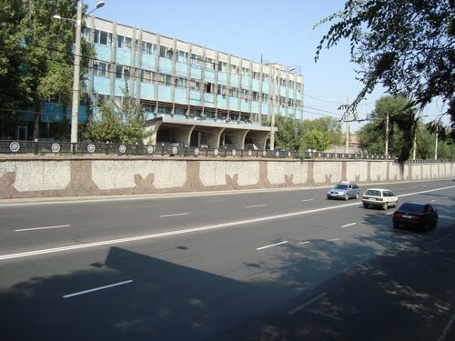
Завод имени В.И.Ленина
ENGLISH Plant named after V.I. Lenin
Plant management building.
Source: https://bimap.su/description/frunze/.txt · BIMAP
Фотографии и материалы принадлежат их авторам; лицензия не указана

BISHKEK
No information has been found for this period yet
42.86184, 74.58660

Фотография пока не добавлена
ENGLISH
No information has been found for this period yet.

