PISHPEK
No information has been found for this period yet
42.87330, 74.60737

Фотография пока не добавлена
ENGLISH
No information has been found for this period yet.

FRUNZE
Prosecutor's Office
42.87330, 74.60737
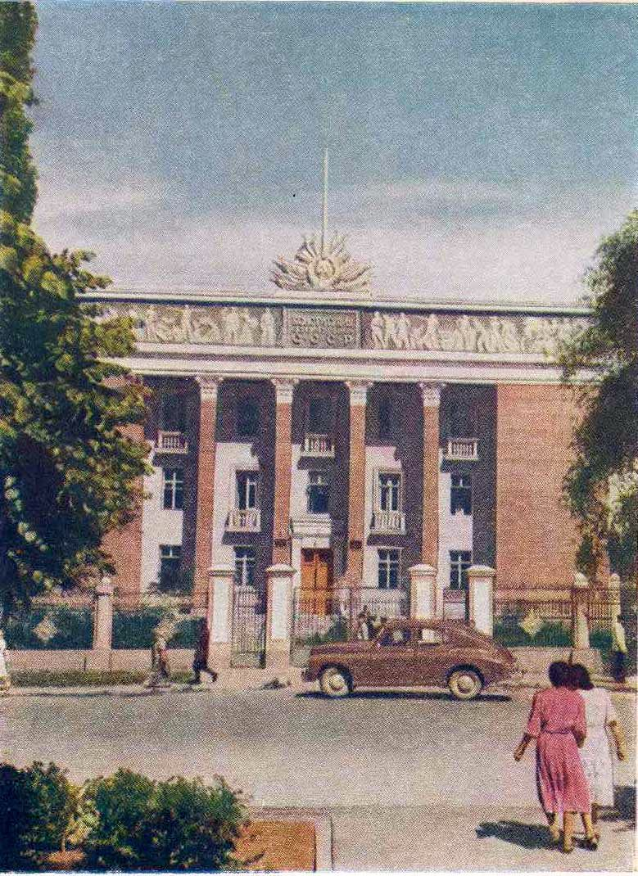
Прокуратура · Д.Шоломовича
ENGLISH Prosecutor's Office
﻿ Prosecutor's Office Prosecutor's Office. Photo by D. Sholomovich, 1957. Architect V. Veryuzhsky, 1941. The building is crowned with the coat of arms of the USSR. The white square used to have the inscription “The Constitution is the fundamental law of the USSR.” Photo by Evgeny Korovin. The symbol of the union of workers and peasants is sheaves with sickles and an anvil. Photo by Evgeny Korovin. On the frieze of the building there are panels by
Source: https://bimap.su/description/frunze/351_Prokuratura.txt · BIMAP
Фотографии и материалы принадлежат их авторам; лицензия не указана

BISHKEK
Prosecutor's Office building
42.87330, 74.60737
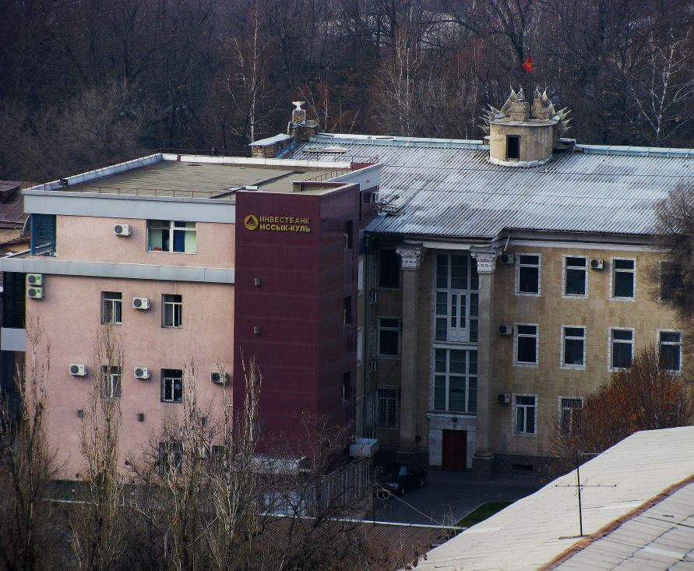
Здание Прокуратуры · Евгения Коровина
ENGLISH Prosecutor's Office building
Prosecutor's office building. View from the east.
Source: https://bimap.su/description/bishkek/116_IMG_1261.txt · BIMAP
Фотографии и материалы принадлежат их авторам; лицензия не указана

