PISHPEK
No information has been found for this period yet
42.86415, 74.58884

Фотография пока не добавлена
ENGLISH
No information has been found for this period yet.

FRUNZE
Tyazhelektromash
42.86415, 74.58884
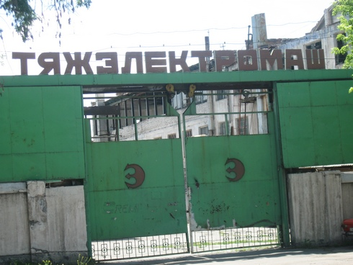
Тяжэлектромаш
ENGLISH Tyazhelektromash
﻿ Tyazhelektromash Frunze Heavy Engineering Plant was organized in 1958. It produced electrical machines, transformers, and electrical equipment. In 1982 there were 1,417 employees.
Source: https://bimap.su/description/frunze/350_Zavod.txt · BIMAP
Фотографии и материалы принадлежат их авторам; лицензия не указана

BISHKEK
Ruins of the Tyazhelektromash plant
42.86415, 74.58884
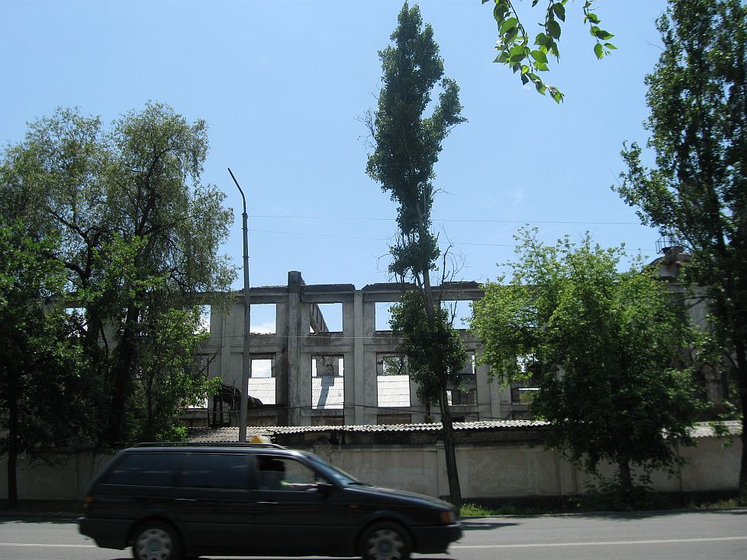
Руины завода Тяжэлектромаш · Владимира Петрова
ENGLISH Ruins of the Tyazhelektromash plant
Ruins of the Tyazhelektromash plant Ruins of the Tyazhelektromash plant.
Source: https://bimap.su/description/bishkek/93_IMG_3525.txt · BIMAP
Фотографии и материалы принадлежат их авторам; лицензия не указана

