PISHPEK
No information has been found for this period yet
42.87361, 74.60462

Фотография пока не добавлена
ENGLISH
No information has been found for this period yet.

FRUNZE
Women's Pedagogical Institute
42.87361, 74.60462
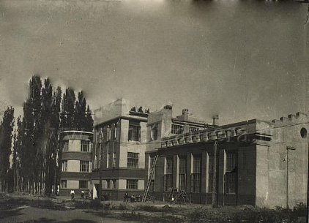
Женпединститут
ENGLISH Women's Pedagogical Institute
The building of the Women's Pedagogical Institute named after. V.V. Mayakovsky. Architect Yu.B. Dubov, 1933 It was opened in 1934 as the Kyrgyz State Pedagogical Institute. During the war years, the command engineering department of the Military Engineering Academy named after. V.G.Kuibysheva.
Source: https://bimap.su/description/frunze/349_Jenped.txt · BIMAP
Фотографии и материалы принадлежат их авторам; лицензия не указана

BISHKEK
No information has been found for this period yet
42.87361, 74.60462

Фотография пока не добавлена
ENGLISH
No information has been found for this period yet.

