PISHPEK
No information has been found for this period yet
42.86932, 74.60365

Фотография пока не добавлена
ENGLISH
No information has been found for this period yet.

FRUNZE
Scriabin's House
42.86932, 74.60365
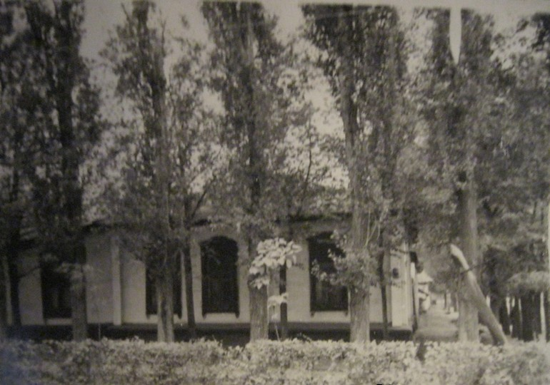
Домик Скрябина
ENGLISH Scriabin's House
﻿ Scriabin's House Academician Konstantin Ivanovich Scriabin (1878-1972), Russian and Soviet biologist, Hero of Socialist Labor, laureate of the Lenin and Stalin Prizes, lived in this house. One of the founders of the Kyrgyz branch of the USSR Academy of Sciences and the first Chairman of the presidium of this branch. Academicians A.N. visited Scriabin’s house. Bakh, A.A. Borisyak, V.A. Engelhardt - everyone who stood at the origins of the creati
Source: https://bimap.su/description/frunze/347_Dom_Skriabina.txt · BIMAP
Фотографии и материалы принадлежат их авторам; лицензия не указана

BISHKEK
No information has been found for this period yet
42.86932, 74.60365

Фотография пока не добавлена
ENGLISH
No information has been found for this period yet.

