PISHPEK
No information has been found for this period yet
42.86567, 74.61030

Фотография пока не добавлена
ENGLISH
No information has been found for this period yet.

FRUNZE
Chuikov's House
42.86567, 74.61030
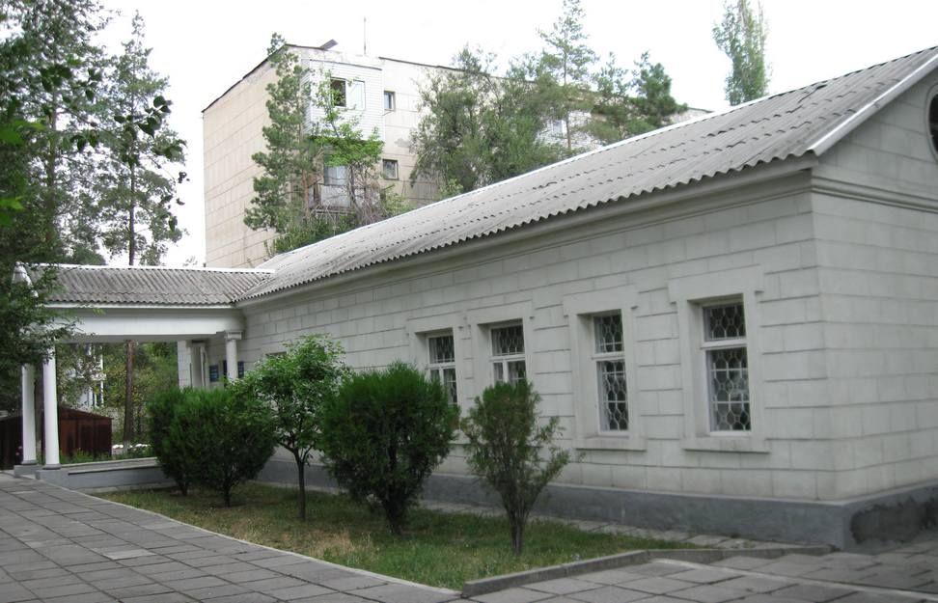
Дом Чуйкова
ENGLISH Chuikov's House
﻿ Chuikov's House This house on Yuzhnaya Street (Chuikova) was built as an art studio-workshop in 1937. The Hungarian sculptor Laszlo Messaros lived and worked in it. He participated in the design of artistic panels in the halls of the railway station, and made sketches of friezes for the Government House. His hands made the decorative lampshades and carved doors of the meeting room in this building. Later, the artist Semyon Chuikov lived and wor
Source: https://bimap.su/description/frunze/344_Dom_Chuikova.txt · BIMAP
Фотографии и материалы принадлежат их авторам; лицензия не указана

BISHKEK
No information has been found for this period yet
42.86567, 74.61030

Фотография пока не добавлена
ENGLISH
No information has been found for this period yet.

