PISHPEK
No information has been found for this period yet
42.87714, 74.61132

Фотография пока не добавлена
ENGLISH
No information has been found for this period yet.

FRUNZE
House of "Pamirstroy"
42.87714, 74.61132
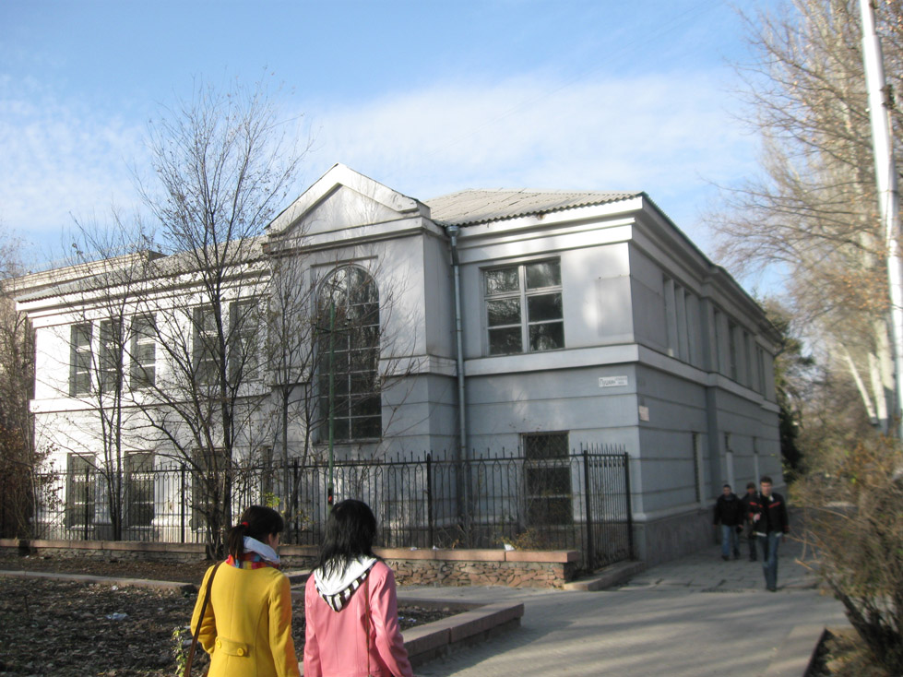
Дом «Памирстроя»
ENGLISH House of "Pamirstroy"
﻿ House of Pamirstroy This house was built in 1935 for the organization "Stroyshossdor No. 1 (Pamirstroy)". This organization, which completed the construction of the road and retained the name “Pamirstroy,” relocated to Frunze and began work on the construction of the Great Kyrgyz Highway. The total length of the new road was 969 km. From the city of Frunze through Rybachye and Naryn it went out to the Torugart pass and had a branch through the
Source: https://bimap.su/description/frunze/342_Dom_Pamirstroia.txt · BIMAP
Фотографии и материалы принадлежат их авторам; лицензия не указана

BISHKEK
No information has been found for this period yet
42.87714, 74.61132

Фотография пока не добавлена
ENGLISH
No information has been found for this period yet.

