PISHPEK
No information has been found for this period yet
42.87432, 74.64170

Фотография пока не добавлена
ENGLISH
No information has been found for this period yet.

FRUNZE
KSK
42.87432, 74.64170
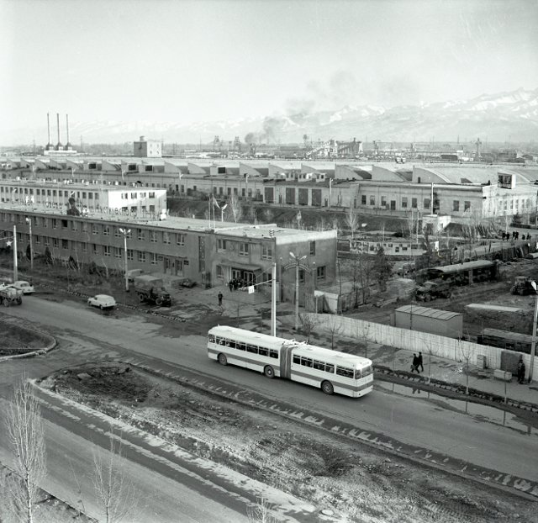
КСК
ENGLISH KSK
﻿ KSK Worsted and Cloth Mill. Photo from 1984 Kyrgyz Worsted and Cloth Factory. In 1963 the 1st stage was put into operation. In 1962, a cloth factory was merged with the plant under construction. It produces suit and dress fabrics using synthetic fibers, coat fabrics, wool blend drapes, blankets, and yarn. The main production building of the plant occupies an area of ​​60 thousand square meters. A town with residential buildings, a children's ce
Source: https://bimap.su/description/frunze/339_KSK.txt · BIMAP
Фотографии и материалы принадлежат их авторам; лицензия не указана

BISHKEK
No information has been found for this period yet
42.87432, 74.64170

Фотография пока не добавлена
ENGLISH
No information has been found for this period yet.

