PISHPEK
No information has been found for this period yet
42.84228, 74.58543

Фотография пока не добавлена
ENGLISH
No information has been found for this period yet.

FRUNZE
Mira Avenue
42.84228, 74.58543
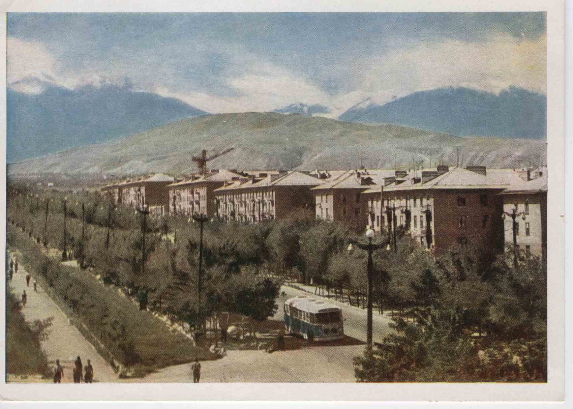
Проспект Мира
ENGLISH Mira Avenue
﻿ Construction of the first microdistrict on Mira Avenue In 1953. the street received the name Novo-Belinskaya, and in July 1960. renamed to Mira Avenue. It stretches from the railway crossing, which came into operation in 1972, to the Airport, which was closed in 1980. in connection with the commissioning of the new Manas airport. Nowadays you can see quite a few multi-storey buildings on the avenue. All of them were built in the post-war period
Source: https://bimap.su/description/frunze/337_Prospekt_Mira.txt · BIMAP
Фотографии и материалы принадлежат их авторам; лицензия не указана

BISHKEK
No information has been found for this period yet
42.84228, 74.58543

Фотография пока не добавлена
ENGLISH
No information has been found for this period yet.

