PISHPEK
No information has been found for this period yet
42.87614, 74.61365

Фотография пока не добавлена
ENGLISH
No information has been found for this period yet.

FRUNZE
Fountain
42.87614, 74.61365
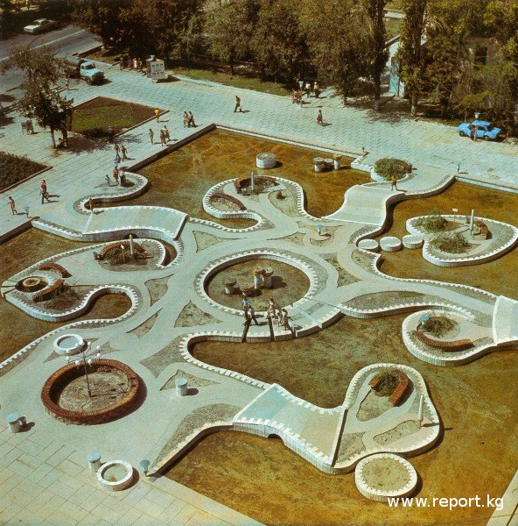
Фонтан
ENGLISH Fountain
﻿ Fountain near the Central Department Store During the reconstruction and landscaping of the city center and the construction of public buildings and structures, fountains are built. Fountain at the Central Department Store (architect R. Mukhamadiev, A. Soltobaev and others, 1977).
Source: https://bimap.su/description/frunze/334_Fontan.txt · BIMAP
Фотографии и материалы принадлежат их авторам; лицензия не указана

BISHKEK
No information has been found for this period yet
42.87614, 74.61365

Фотография пока не добавлена
ENGLISH
No information has been found for this period yet.

