PISHPEK
Eastern side of Bazarnaya street
42.88002, 74.61178
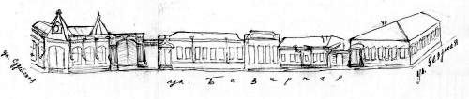
Восточная сторона улицы Базарной
ENGLISH Eastern side of Bazarnaya street
﻿ Eastern side of Bazarnaya street between Sudeiskaya and Uezdnaya. Reconstruction of Petrov. While the construction of residential buildings in the city of Pishpek was carried out strictly according to plan, when there were two or three estates in one block, the development of shopping streets became denser, and the block was built up with a continuous series of shops and stores. The shops of prominent merchants were built from baked bricks with
Source: https://bimap.su/description/pishpek/54_Vostok_Bazarnoi.txt · BIMAP
Фотографии и материалы принадлежат их авторам; лицензия не указана

FRUNZE
No information has been found for this period yet
42.88002, 74.61178

Фотография пока не добавлена
ENGLISH
No information has been found for this period yet.

BISHKEK
No information has been found for this period yet
42.88002, 74.61178

Фотография пока не добавлена
ENGLISH
No information has been found for this period yet.

