PISHPEK
No information has been found for this period yet
42.87592, 74.57984

Фотография пока не добавлена
ENGLISH
No information has been found for this period yet.

FRUNZE
Orphanage
42.87592, 74.57984
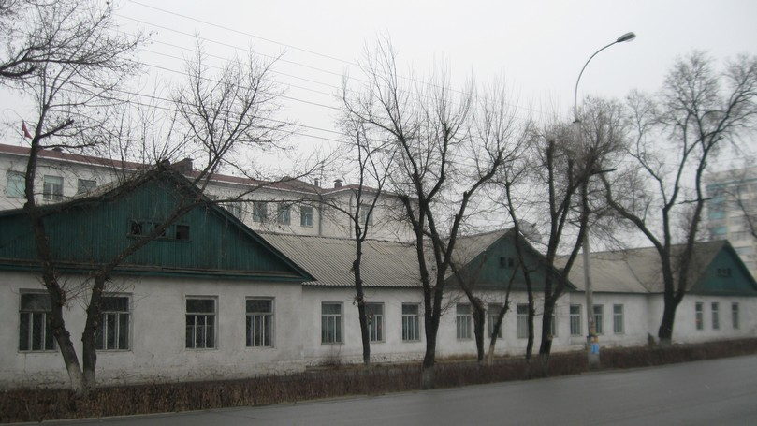
Детский дом
ENGLISH Orphanage
﻿ Dormitory building for girls of the Krupskaya Orphanage This is all that remains of the orphanage buildings that occupied from 1930 to the 60s the territory in the blocks of Dunganska (Kyiv), Sverdlova (Umetalieva), Pushkin, Sokulukskaya (Akieva) streets. There were living quarters, a club and workshops - sewing, plumbing, carpentry, shoemaking, and utility work. Orphanage named after. N.K. Krupskoy received hundreds of children orphaned during
Source: https://bimap.su/description/frunze/329_Detdom.txt · BIMAP
Фотографии и материалы принадлежат их авторам; лицензия не указана

BISHKEK
No information has been found for this period yet
42.87592, 74.57984

Фотография пока не добавлена
ENGLISH
No information has been found for this period yet.

