PISHPEK
No information has been found for this period yet
42.88650, 74.60965

Фотография пока не добавлена
ENGLISH
No information has been found for this period yet.

FRUNZE
Palace of Pioneers
42.88650, 74.60965
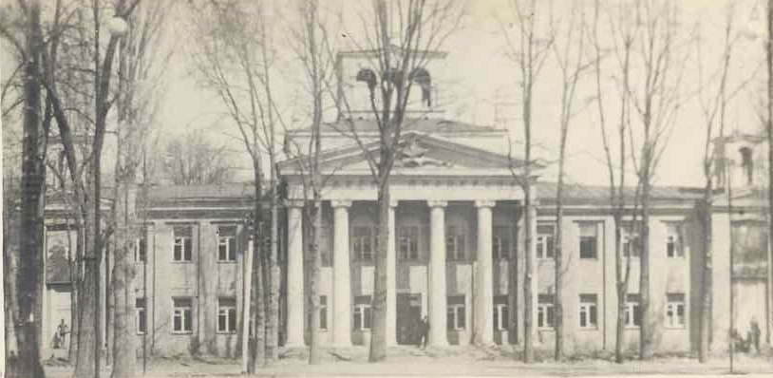
Дворец пионеров
ENGLISH Palace of Pioneers
﻿ Palace of Pioneers Construction of the building began in 1939 according to the design of the architect F.P. Steblin. Construction was completed in 1951 according to the design of architect V.E. Nusov.
Source: https://bimap.su/description/frunze/327_Dvorez_pionerov.txt · BIMAP
Фотографии и материалы принадлежат их авторам; лицензия не указана

BISHKEK
No information has been found for this period yet
42.88650, 74.60965

Фотография пока не добавлена
ENGLISH
No information has been found for this period yet.

