PISHPEK
No information has been found for this period yet
42.87890, 74.60212

Фотография пока не добавлена
ENGLISH
No information has been found for this period yet.

FRUNZE
Theater
42.87890, 74.60212
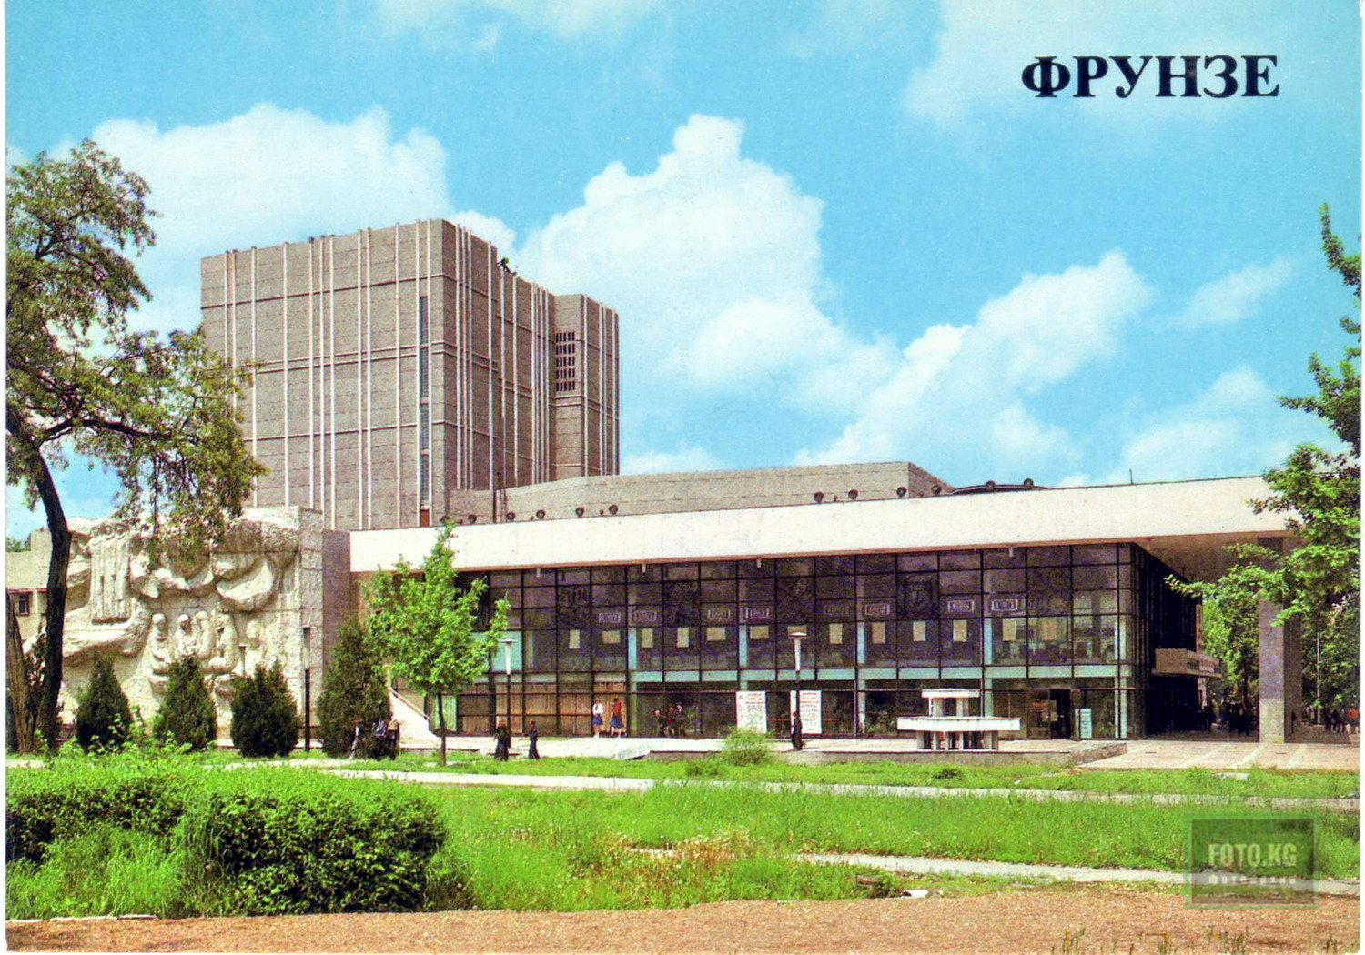
Театр
ENGLISH Theater
﻿ The building of the Kyrgyz Academic Drama Theater The building of the Kyrgyz Academic Drama Theater. Photo 1970 Architects F.M.Evseev, M.G.Evseeva, engineers V.V.Zharkova, A.A.Antonova, 1970 Kyrgyz Drama Theater - created in 1941 in Frunze on the basis of the 1st Kyrgyz Professional Drama Theater (1930). The theater was awarded the Order of the Red Banner of Labor (1958), and was given the title of academic (1971). Artistic panels on the theate
Source: https://bimap.su/description/frunze/325_Teatr.txt · BIMAP
Фотографии и материалы принадлежат их авторам; лицензия не указана

BISHKEK
No information has been found for this period yet
42.87890, 74.60212

Фотография пока не добавлена
ENGLISH
No information has been found for this period yet.

