PISHPEK
City Council building
42.87953, 74.61211
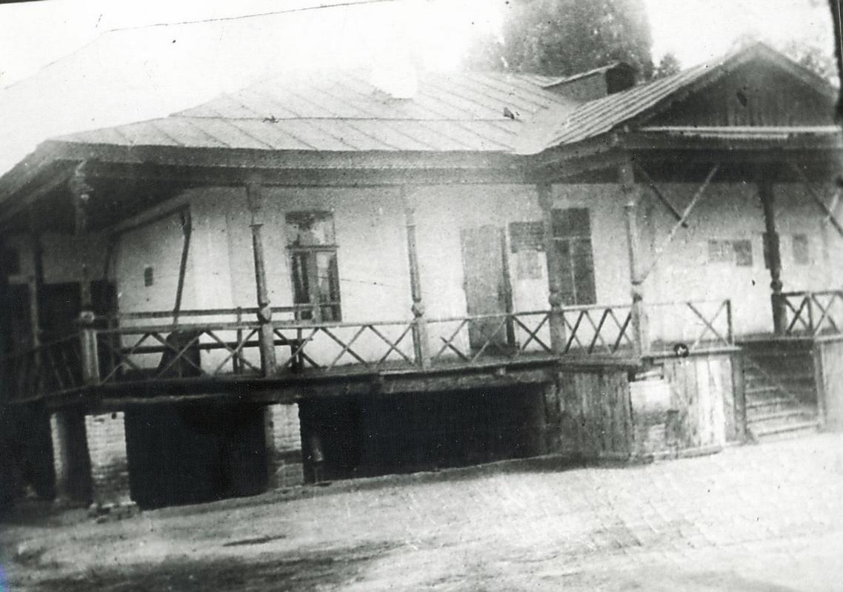
Здание горсовета
ENGLISH City Council building
﻿ The building of the City Council of Deputies and Workers on Uyezdnaya. View from the yard. The end of the 19th and beginning of the 20th centuries was characterized by the improvement of the city and the construction of large houses at the head of the city estate. The houses stood on high stone foundations made of cobblestones or ashlars, above which there was a brick basement with a patterned decor of the brickwork. The walls of the upper floo
Source: https://bimap.su/description/pishpek/53_Gorsovet.txt · BIMAP
Фотографии и материалы принадлежат их авторам; лицензия не указана

FRUNZE
No information has been found for this period yet
42.87953, 74.61211

Фотография пока не добавлена
ENGLISH
No information has been found for this period yet.

BISHKEK
No information has been found for this period yet
42.87953, 74.61211

Фотография пока не добавлена
ENGLISH
No information has been found for this period yet.

