PISHPEK
No information has been found for this period yet
42.88397, 74.60646

Фотография пока не добавлена
ENGLISH
No information has been found for this period yet.

FRUNZE
KGB building
42.88397, 74.60646
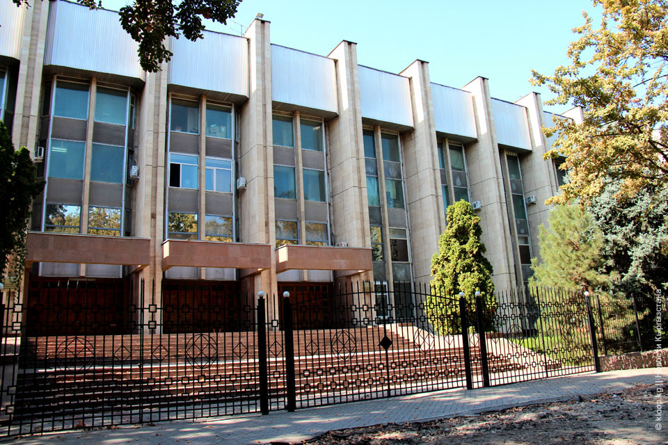
Здание КГБ
ENGLISH KGB building
﻿ Administrative building of the KGB of the Kirghiz SSR Administrative building of the KGB of the Kirghiz SSR
Source: https://bimap.su/description/frunze/314_GKNB.txt · BIMAP
Фотографии и материалы принадлежат их авторам; лицензия не указана

BISHKEK
No information has been found for this period yet
42.88397, 74.60646

Фотография пока не добавлена
ENGLISH
No information has been found for this period yet.

