PISHPEK
House on the corner of Tashkentskaya and Bazarnaya streets
42.88512, 74.61200
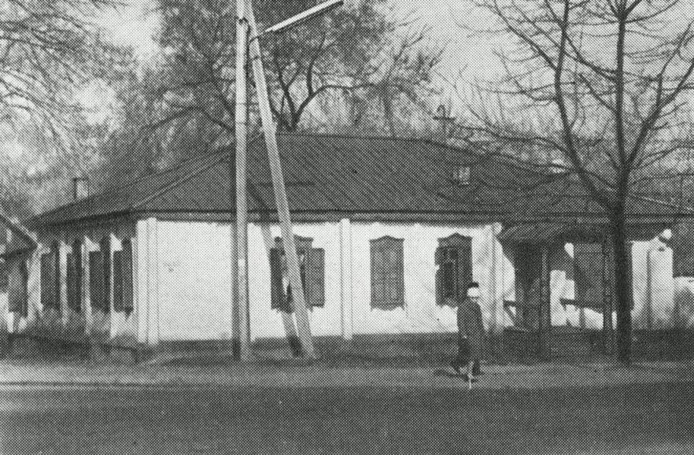
Дом на углу улиц Ташкентской и Базарной
ENGLISH House on the corner of Tashkentskaya and Bazarnaya streets
﻿ House on the north-eastern corner of Tashkentskaya and Bazarnaya streets. The beginning of the 20th century The end of the 19th and beginning of the 20th centuries was characterized by the improvement of the city and the construction of large houses at the head of the city estate. The houses stood on high stone foundations made of cobblestones or ashlars, above which there was a brick basement with a patterned decor of the brickwork. The walls
Source: https://bimap.su/description/pishpek/52_Dom_ugol_Tashkent_Bazar.txt · BIMAP
Фотографии и материалы принадлежат их авторам; лицензия не указана

FRUNZE
No information has been found for this period yet
42.88512, 74.61200

Фотография пока не добавлена
ENGLISH
No information has been found for this period yet.

BISHKEK
No information has been found for this period yet
42.88512, 74.61200

Фотография пока не добавлена
ENGLISH
No information has been found for this period yet.

