PISHPEK
No information has been found for this period yet
42.87921, 74.61615

Фотография пока не добавлена
ENGLISH
No information has been found for this period yet.

FRUNZE
Victory Square and Monument
42.87921, 74.61615
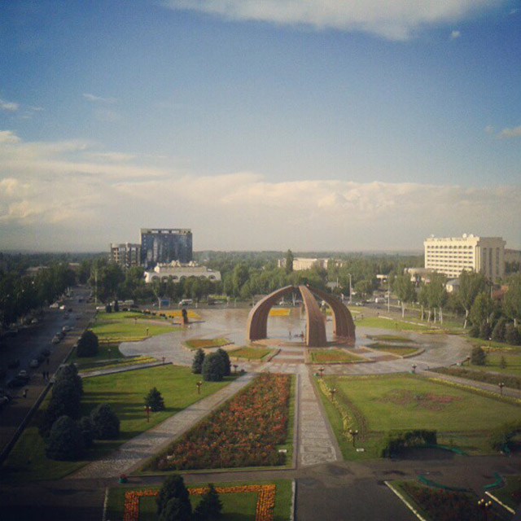
Площадь и памятник Победы
ENGLISH Victory Square and Monument
﻿ Victory Square and Monument The architectural and sculptural composition was built in 1985, on the 40th anniversary of the victory in World War II. Sculptors T. Sadykov, M. K. Anikushkin, architects - V. Lyzenko, V. B. Bukhaev. Three stone arches represent a yurt in which a woman stands over the eternal fire, awaiting the return of her husband and sons from the war. Two other compositions: a sculptural image of soldiers carrying a machine gun,
Source: https://bimap.su/description/frunze/312_Pobeda.txt · BIMAP
Фотографии и материалы принадлежат их авторам; лицензия не указана

BISHKEK
No information has been found for this period yet
42.87921, 74.61615

Фотография пока не добавлена
ENGLISH
No information has been found for this period yet.

