PISHPEK
No information has been found for this period yet
42.86715, 74.60675

Фотография пока не добавлена
ENGLISH
No information has been found for this period yet.

FRUNZE
House on Dzerzhinka
42.86715, 74.60675
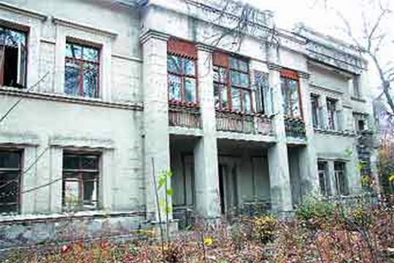
Дом на Дзержинке
ENGLISH House on Dzerzhinka
﻿ The first two-story houses on Dzerzhinka The first two-story houses on Dzerzhinka
Source: https://bimap.su/description/frunze/310_Dzerjinka.txt · BIMAP
Фотографии и материалы принадлежат их авторам; лицензия не указана

BISHKEK
No information has been found for this period yet
42.86715, 74.60675

Фотография пока не добавлена
ENGLISH
No information has been found for this period yet.

