PISHPEK
No information has been found for this period yet
42.86401, 74.60589

Фотография пока не добавлена
ENGLISH
No information has been found for this period yet.

FRUNZE
Frunze Station
42.86401, 74.60589
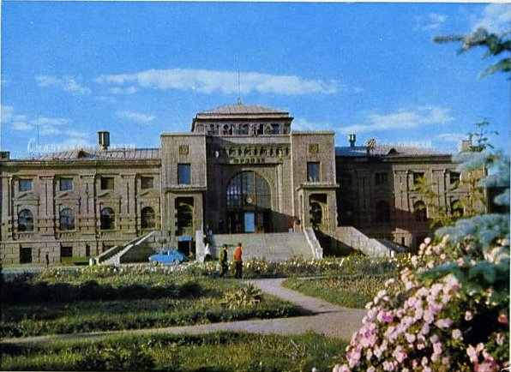
Вокзал Фрунзе
ENGLISH Frunze Station
﻿ Frunze Station The building of the Frunze railway passenger station. Built in 1938, architect E. Limar. The interior of the building is decorated with columns, capitals, colored ceiling paintings, decorative sculptural stucco and heraldry, sculptor L. Messarosh, artist A. Ignatiev. On May 25, 1930, Frunze station was opened to traffic. On this day, the first train to Tashkent left from here. This is what Frunze station looked like in 1932. Phot
Source: https://bimap.su/description/frunze/307_Vokzal1.txt · BIMAP
Фотографии и материалы принадлежат их авторам; лицензия не указана

BISHKEK
Train station
42.86401, 74.60589
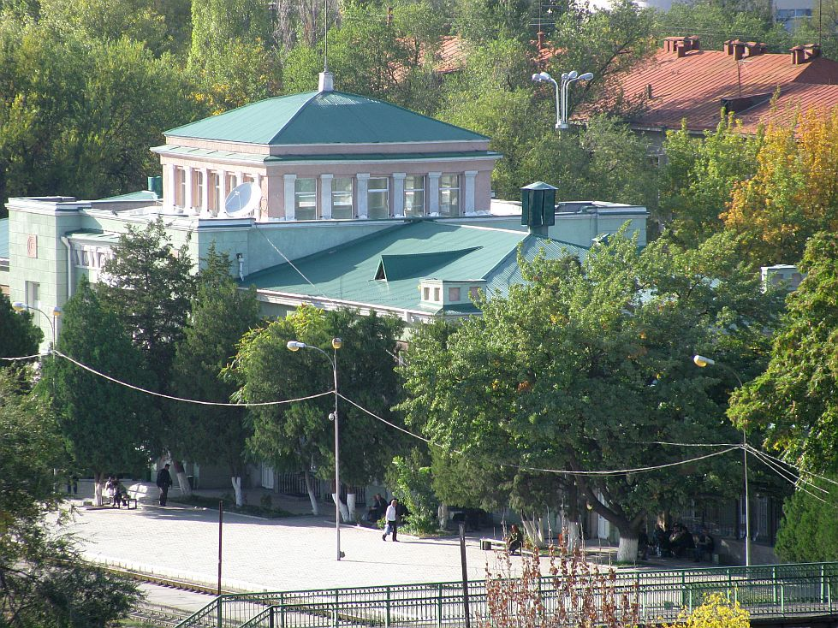
Вокзал · Евгения Коровина
ENGLISH Train station
Bishkek-2 railway station Train station Bishkek-2 railway station.
Source: https://bimap.su/description/bishkek/68_IMG_0894.txt · BIMAP
Фотографии и материалы принадлежат их авторам; лицензия не указана

