PISHPEK
No information has been found for this period yet
42.84895, 74.58562

Фотография пока не добавлена
ENGLISH
No information has been found for this period yet.

FRUNZE
"Baychechekey"
42.84895, 74.58562
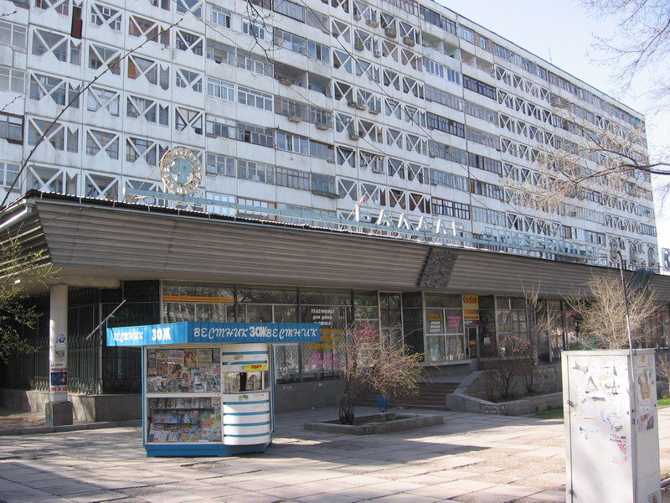
«Байчечекей»
ENGLISH "Baychechekey"
﻿ "Baychechekey" In the 80s, construction was completed on Mira Avenue and a number of new buildings were put into operation. Among them, first of all, we can highlight a twelve-story residential building with a Baychechekei department store on the ground floor. This is the second largest large shopping center in the city, selling goods for children. Grocery store "School-store" and beauty salon "Ai-peri". In 1982, a branch of "Children's World"
Source: https://bimap.su/description/frunze/305_Baiche.txt · BIMAP
Фотографии и материалы принадлежат их авторам; лицензия не указана

BISHKEK
No information has been found for this period yet
42.84895, 74.58562

Фотография пока не добавлена
ENGLISH
No information has been found for this period yet.

