PISHPEK
No information has been found for this period yet
42.87000, 74.60686

Фотография пока не добавлена
ENGLISH
No information has been found for this period yet.

FRUNZE
Ministry of State Farms
42.87000, 74.60686
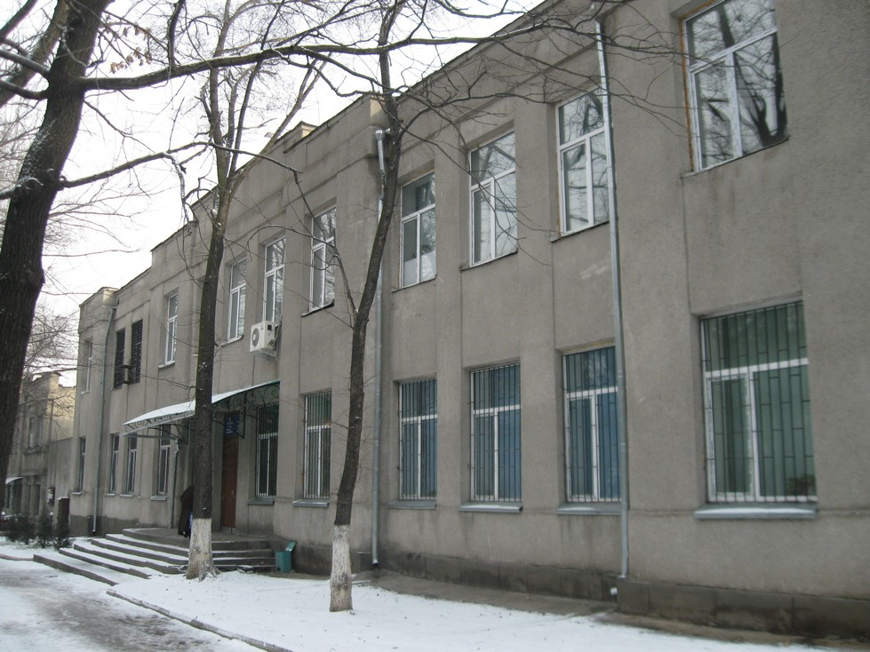
Министерство совхозов · Владимира Петрова
ENGLISH Ministry of State Farms
﻿ This building was built as the Ministry of State Farms This building was built as the Ministry of State Farms.
Source: https://bimap.su/description/frunze/304_Minsovhoz.txt · BIMAP
Фотографии и материалы принадлежат их авторам; лицензия не указана

BISHKEK
No information has been found for this period yet
42.87000, 74.60686

Фотография пока не добавлена
ENGLISH
No information has been found for this period yet.

