PISHPEK
No information has been found for this period yet
42.87052, 74.60698

Фотография пока не добавлена
ENGLISH
No information has been found for this period yet.

FRUNZE
House on Dzerzhinka. Photo by Petrov
42.87052, 74.60698
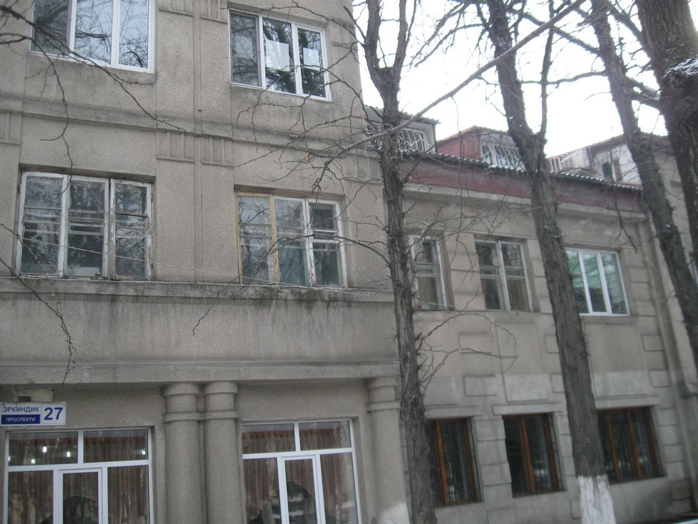
Дом на Дзержинке. Фото Петрова
ENGLISH House on Dzerzhinka. Photo by Petrov
﻿ House on Dzerzhinka House on Dzerzhinka with elements of constructivism. One of the first 2-story residential buildings in the city, built in the 30s. In the 1941 extension is the registry office archive. Once upon a time, journalist Alexander Tuzov wrote that “we all come from 1941”... It is behind these walls that there is data about almost every resident of the city. Photo by Vladimir Petrov.
Source: https://bimap.su/description/frunze/303_ZAGS.txt · BIMAP
Фотографии и материалы принадлежат их авторам; лицензия не указана

BISHKEK
No information has been found for this period yet
42.87052, 74.60698

Фотография пока не добавлена
ENGLISH
No information has been found for this period yet.

