PISHPEK
City house of the early 20th century
42.88577, 74.61201
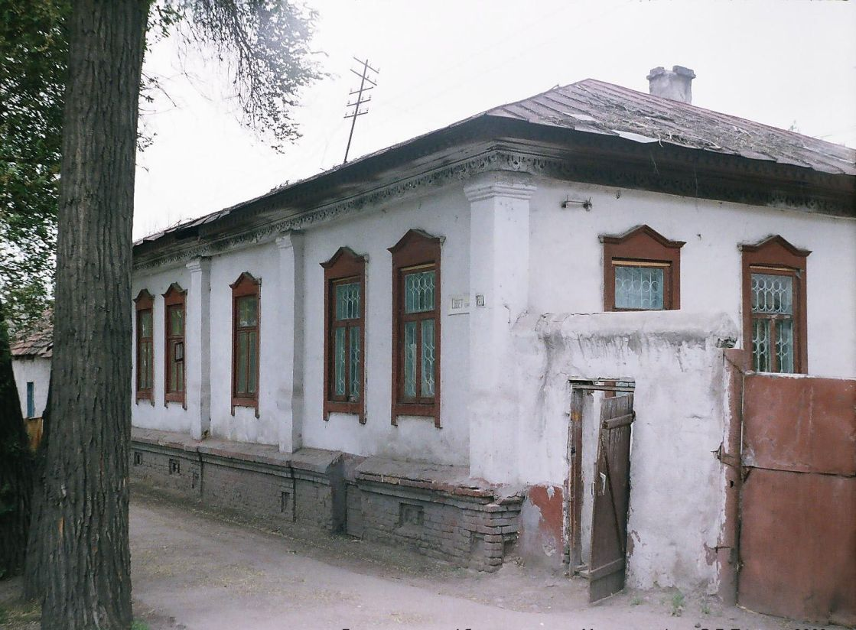
Городской дом начала ХХ века · Владимира Петрова
ENGLISH City house of the early 20th century
, Bazarnaya Street above Ilyinskaya The end of the 19th - beginning of the 20th centuries is characterized by the improvement of the city and the construction of large houses at the head of the city estate. The houses stood on high stone foundations made of cobblestones or ashlars, above which there was a brick basement with a patterned decor of the brickwork. The walls of the upper floors are frame-wooden or log. The number of rooms was determin
Source: https://bimap.su/description/pishpek/51_Dom_na_Bazar_vishe_Ilin.txt · BIMAP
Фотографии и материалы принадлежат их авторам; лицензия не указана

FRUNZE
No information has been found for this period yet
42.88577, 74.61201

Фотография пока не добавлена
ENGLISH
No information has been found for this period yet.

BISHKEK
No information has been found for this period yet
42.88577, 74.61201

Фотография пока не добавлена
ENGLISH
No information has been found for this period yet.

