PISHPEK
No information has been found for this period yet
42.87442, 74.60578

Фотография пока не добавлена
ENGLISH
No information has been found for this period yet.

FRUNZE
House on Dzerzhinka
42.87442, 74.60578
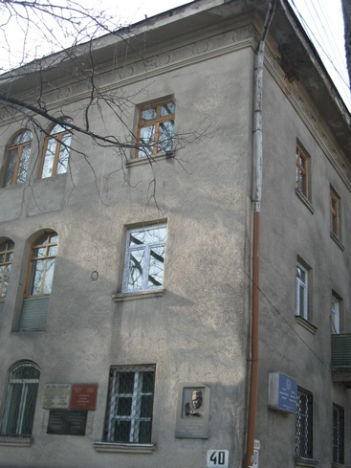
Дом на Дзержинке · Владимира Петрова
ENGLISH House on Dzerzhinka
﻿ Academic house on Dzerzhinka, built in the 50s Memorial plaques on the house to academicians D.A. Alyshbaev, I. Akhunbaev, scientists I. Batmanov, V. Yakovlev.
Source: https://bimap.su/description/frunze/302_Dzerjinka.txt · BIMAP
Фотографии и материалы принадлежат их авторам; лицензия не указана

BISHKEK
No information has been found for this period yet
42.87442, 74.60578

Фотография пока не добавлена
ENGLISH
No information has been found for this period yet.

