PISHPEK
No information has been found for this period yet
42.86868, 74.59834

Фотография пока не добавлена
ENGLISH
No information has been found for this period yet.

FRUNZE
Building on Logvinenko Street with the coat of arms of the USSR
42.86868, 74.59834
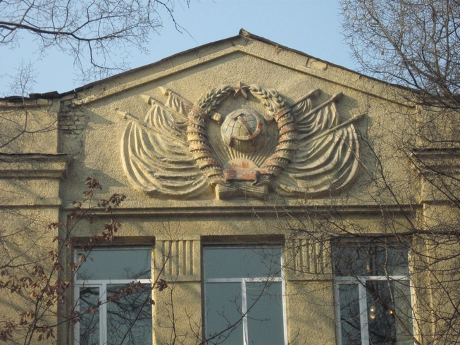
Здание на улице Логвиненко с гербом СССР
ENGLISH Building on Logvinenko Street with the coat of arms of the USSR
﻿ Building on Logvinenko Street with the coat of arms of the USSR Building on Logvinenko Street with the coat of arms of the USSR.
Source: https://bimap.su/description/frunze/300_Logvinenko.txt · BIMAP
Фотографии и материалы принадлежат их авторам; лицензия не указана

BISHKEK
No information has been found for this period yet
42.86868, 74.59834

Фотография пока не добавлена
ENGLISH
No information has been found for this period yet.

