PISHPEK
No information has been found for this period yet
42.87649, 74.59570

Фотография пока не добавлена
ENGLISH
No information has been found for this period yet.

FRUNZE
Mechanical Engineering College.
42.87649, 74.59570
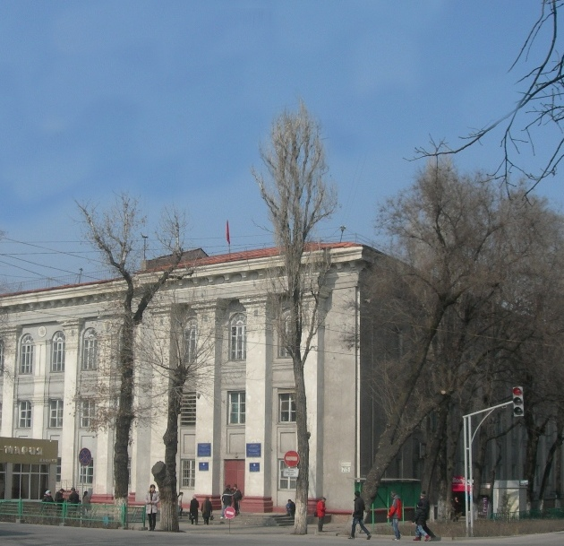
Машиностроительный техникум. · Виктора Глумскова
ENGLISH Mechanical Engineering College.
﻿ Mechanical Engineering College Mechanical Engineering College. Architect E. Pisarskaya, 1966. Architect Evgeny Gavrilovich Pisarskoy (1918–2013). Author of many projects in the city of Frunze: the Kirpotrebsoyuz building (his first project), the Tubin Institute, VDNKh, the Medical Institute, the Institute of Physical Education, the Polytechnic College, the Trade College, the Mechanical Engineering College, the House of Artists, the building of
Source: https://bimap.su/description/frunze/298_Mashtehnikum.txt · BIMAP
Фотографии и материалы принадлежат их авторам; лицензия не указана

BISHKEK
No information has been found for this period yet
42.87649, 74.59570

Фотография пока не добавлена
ENGLISH
No information has been found for this period yet.

