PISHPEK
No information has been found for this period yet
42.84805, 74.61172

Фотография пока не добавлена
ENGLISH
No information has been found for this period yet.

FRUNZE
Radio station
42.84805, 74.61172
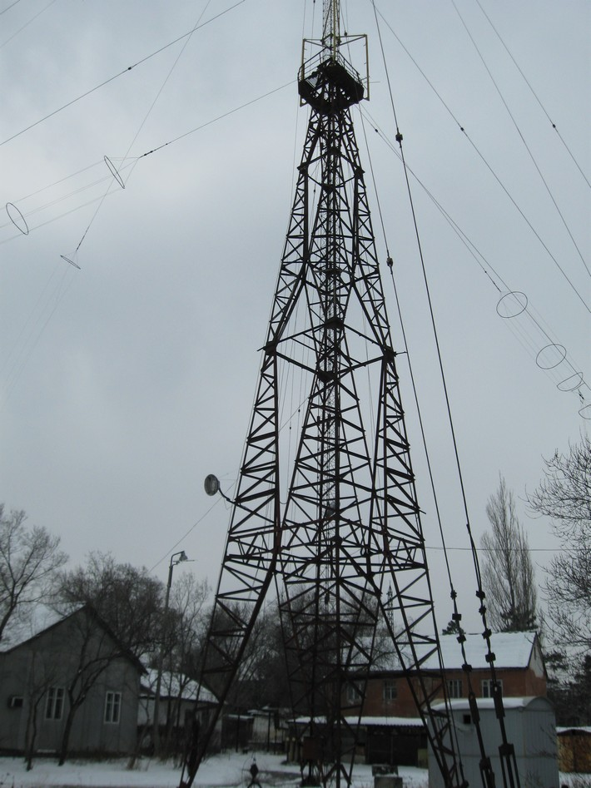
Радиостанция · Владимира Петрова
ENGLISH Radio station
﻿ Radio station The first radio broadcast through city loudspeakers in the city of Frunze took place on March 7, 1927 from the building of the Council of People's Commissars with a message from the 1st Constituent Congress of Soviets on the formation of the Kyrgyz Autonomous Soviet Socialist Republic. In 1936, this broadcasting station was built far outside the city. From that time on, radio coverage of the entire republic began. Photo by Vladimi
Source: https://bimap.su/description/frunze/297_Radiostanzia.txt · BIMAP
Фотографии и материалы принадлежат их авторам; лицензия не указана

BISHKEK
No information has been found for this period yet
42.84805, 74.61172

Фотография пока не добавлена
ENGLISH
No information has been found for this period yet.

