PISHPEK
No information has been found for this period yet
42.84226, 74.61056

Фотография пока не добавлена
ENGLISH
No information has been found for this period yet.

FRUNZE
Tubin Institute
42.84226, 74.61056
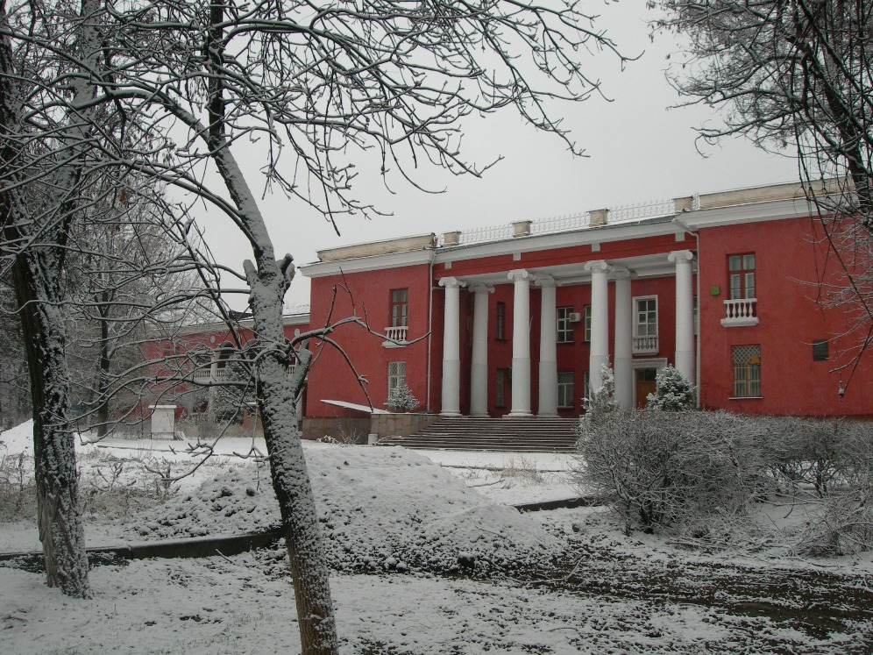
Тубинститут · Виктора Глумскова
ENGLISH Tubin Institute
﻿ Tubin Institute Tuberculosis Institute. Architect E. Pisarskaya, 1950. The Tubin Institute building was built far from the dusty and noisy city streets, when Sovetskaya Street ended, right behind the railway. Architect Evgeny Gavrilovich Pisarskoy (1918–2013). Author of many projects in the city of Frunze: the Kirpotrebsoyuz building (his first project), the Tubin Institute, VDNKh, the Medical Institute, the Institute of Physical Education, the
Source: https://bimap.su/description/frunze/296_Tubinstitut.txt · BIMAP
Фотографии и материалы принадлежат их авторам; лицензия не указана

BISHKEK
No information has been found for this period yet
42.84226, 74.61056

Фотография пока не добавлена
ENGLISH
No information has been found for this period yet.

