PISHPEK
No information has been found for this period yet
42.86341, 74.62327

Фотография пока не добавлена
ENGLISH
No information has been found for this period yet.

FRUNZE
Kirgizavtomash
42.86341, 74.62327
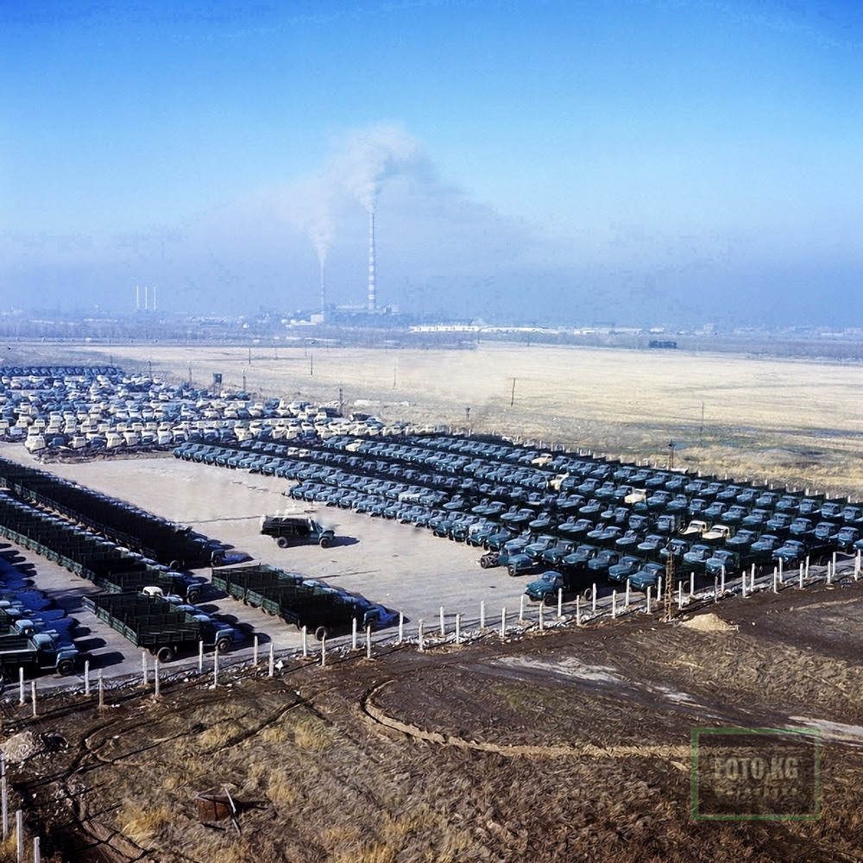
Киргизавтомаш
ENGLISH Kirgizavtomash
﻿ Kirgizavtomash. Finished products. In the background, the Frunzenskaya CHPP, the Kyrgyz Automotive Engineering Plant produces radiators for cooling and heating systems for cars of various brands, hydraulic lifts for dump trucks, side trailers for motorcycles, car and tractor trailers, bodies for dump trucks, tank trucks for water and gasoline, and cast iron for various purposes. Founded in 1947 as a mechanical repair plant on the basis of the p
Source: https://bimap.su/description/frunze/295_Avtomash.txt · BIMAP
Фотографии и материалы принадлежат их авторам; лицензия не указана

BISHKEK
No information has been found for this period yet
42.86341, 74.62327

Фотография пока не добавлена
ENGLISH
No information has been found for this period yet.

