PISHPEK
House of the bailiff Lutin
42.87982, 74.60929
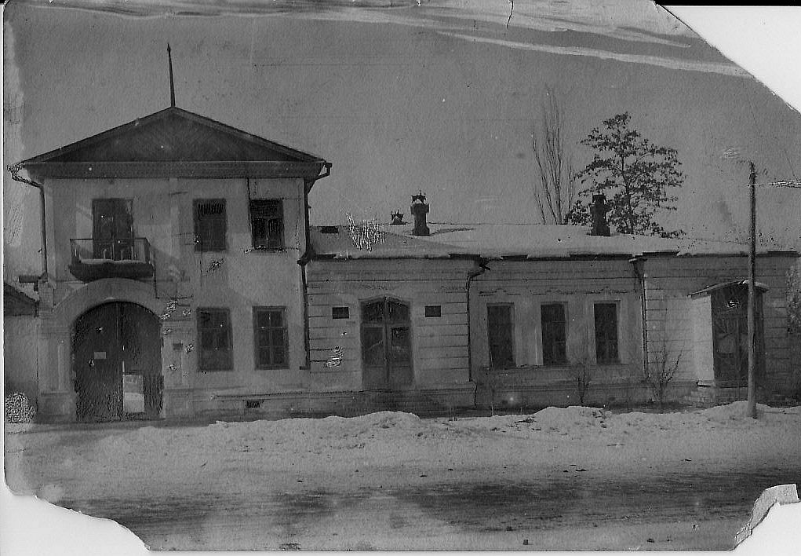
Дом пристава Лутина
ENGLISH House of the bailiff Lutin
﻿ House of the bailiff Lutin on Pushchinskaya This house housed one of the first educational institutions of Pishpek - a 3-grade parish school for girls. Since 1933, the State Museum of Local History has been located here, since 1943 the Museum of National Culture.
Source: https://bimap.su/description/pishpek/5_Dom_Lutina.txt · BIMAP
Фотографии и материалы принадлежат их авторам; лицензия не указана

FRUNZE
Museum of National Culture
42.87982, 74.60929
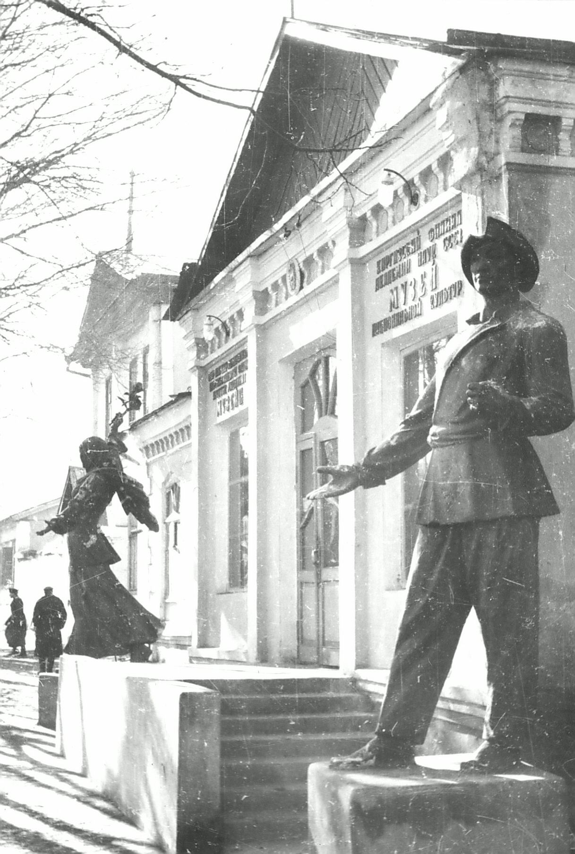
Музей национальной культуры
ENGLISH Museum of National Culture
﻿ Museum of National Culture Museum of National Culture. Photo from TsGAFFKKR, 1950. Founded in 1926 as the central museum of Kyrgyzstan. At first, the exhibition was located in the house where M.V. Frunze was born. Since 1933, it has been transformed into the State Museum of Local History and is located in this building on the street. Krasnooktyabrskaya. Since 1943 it has been called the Museum of National Culture, since 1954 - the Historical Mu
Source: https://bimap.su/description/frunze/150Muzei.txt · BIMAP
Фотографии и материалы принадлежат их авторам; лицензия не указана

BISHKEK
No information has been found for this period yet
42.87982, 74.60929

Фотография пока не добавлена
ENGLISH
No information has been found for this period yet.

