PISHPEK
No information has been found for this period yet
42.87310, 74.60567

Фотография пока не добавлена
ENGLISH
No information has been found for this period yet.

FRUNZE
Kombank
42.87310, 74.60567
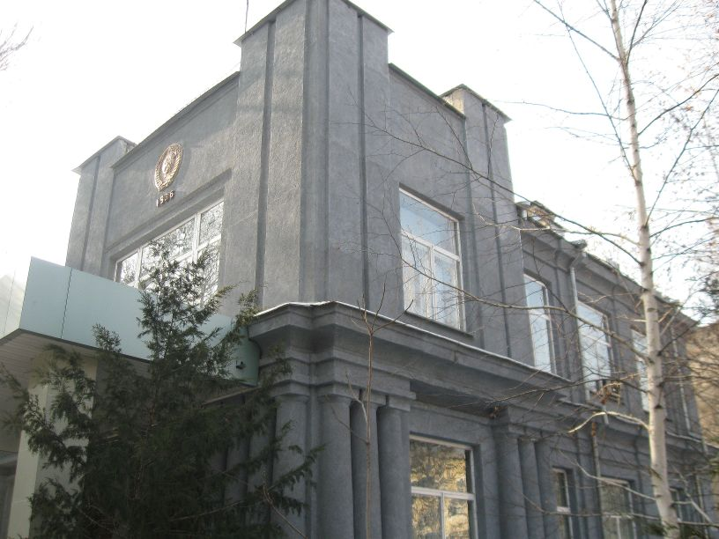
Комбанк
ENGLISH Kombank
﻿ Kombank Bank building built in 1936. During the renovation of the building, the 1936 USSR coat of arms was removed and replaced with the coat of arms of the 50s.
Source: https://bimap.su/description/frunze/292_Kombank.txt · BIMAP
Фотографии и материалы принадлежат их авторам; лицензия не указана

BISHKEK
No information has been found for this period yet
42.87310, 74.60567

Фотография пока не добавлена
ENGLISH
No information has been found for this period yet.

