PISHPEK
No information has been found for this period yet
42.83393, 74.63004

Фотография пока не добавлена
ENGLISH
No information has been found for this period yet.

FRUNZE
Microdistricts
42.83393, 74.63004
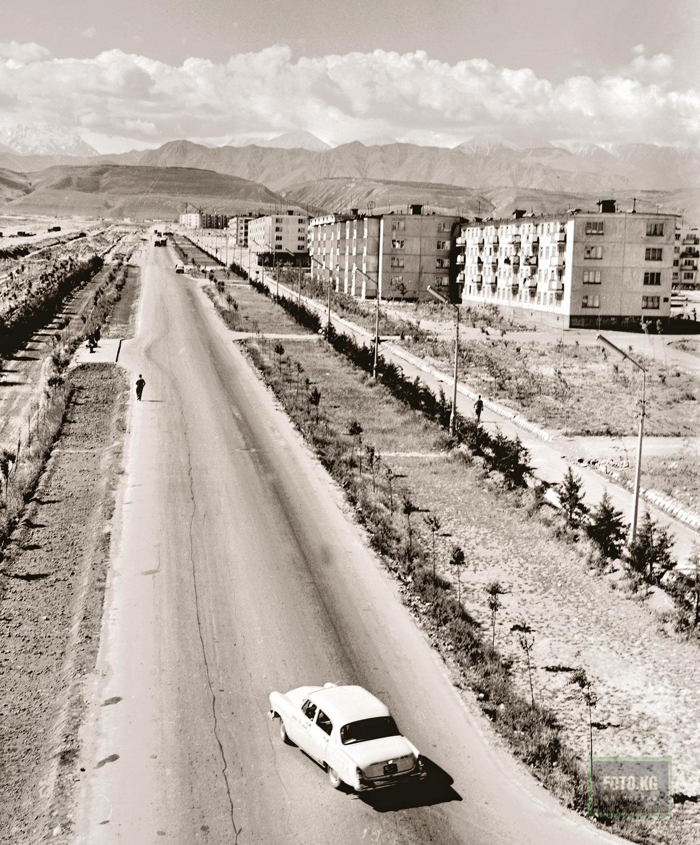
Микрорайоны
ENGLISH Microdistricts
﻿ Microdistricts Construction of the 5th and 6th microdistricts in the south-eastern region of the city. The microdistricts were built up with large-panel houses of series 104 and 105. The authors of the project are architects G. Oganesyan, G. Kutateladze, V. Tychinsky, I. Likhterov and others. The general layout of the 10 southern microdistricts was carried out by M. Muksinov and E. Pisarsky.
Source: https://bimap.su/description/frunze/291_Mikroraiony.txt · BIMAP
Фотографии и материалы принадлежат их авторам; лицензия не указана

BISHKEK
No information has been found for this period yet
42.83393, 74.63004

Фотография пока не добавлена
ENGLISH
No information has been found for this period yet.

