PISHPEK
No information has been found for this period yet
42.87868, 74.61116

Фотография пока не добавлена
ENGLISH
No information has been found for this period yet.

FRUNZE
Museum
42.87868, 74.61116
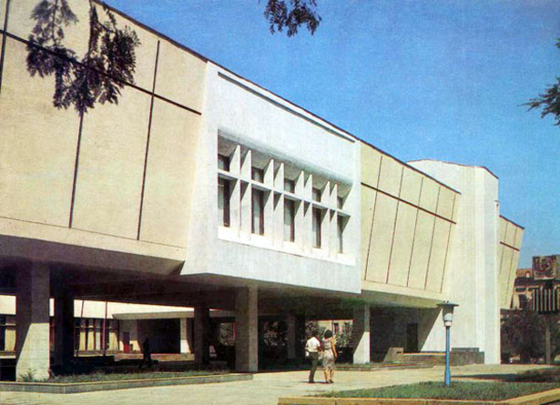
Музей
ENGLISH Museum
﻿ Museum of Fine Arts The museum building was built in 1974. Architects: D. Yryskulov, Sh. Dzhekshenbaev. Initially it was located in the building of the Church of St. Nicholas in Oak Park. Now there is a gallery of the Union of Artists there. The basis of the museum consisted of 72 works of Russian artists, selected from the repositories of the Tretyakov Gallery and 40 works of painting by Kyrgyz artists. The first exhibition was opened on Janua
Source: https://bimap.su/description/frunze/290_Muzei.txt · BIMAP
Фотографии и материалы принадлежат их авторам; лицензия не указана

BISHKEK
No information has been found for this period yet
42.87868, 74.61116

Фотография пока не добавлена
ENGLISH
No information has been found for this period yet.

