PISHPEK
No information has been found for this period yet
42.87560, 74.60487

Фотография пока не добавлена
ENGLISH
No information has been found for this period yet.

FRUNZE
Post Office
42.87560, 74.60487
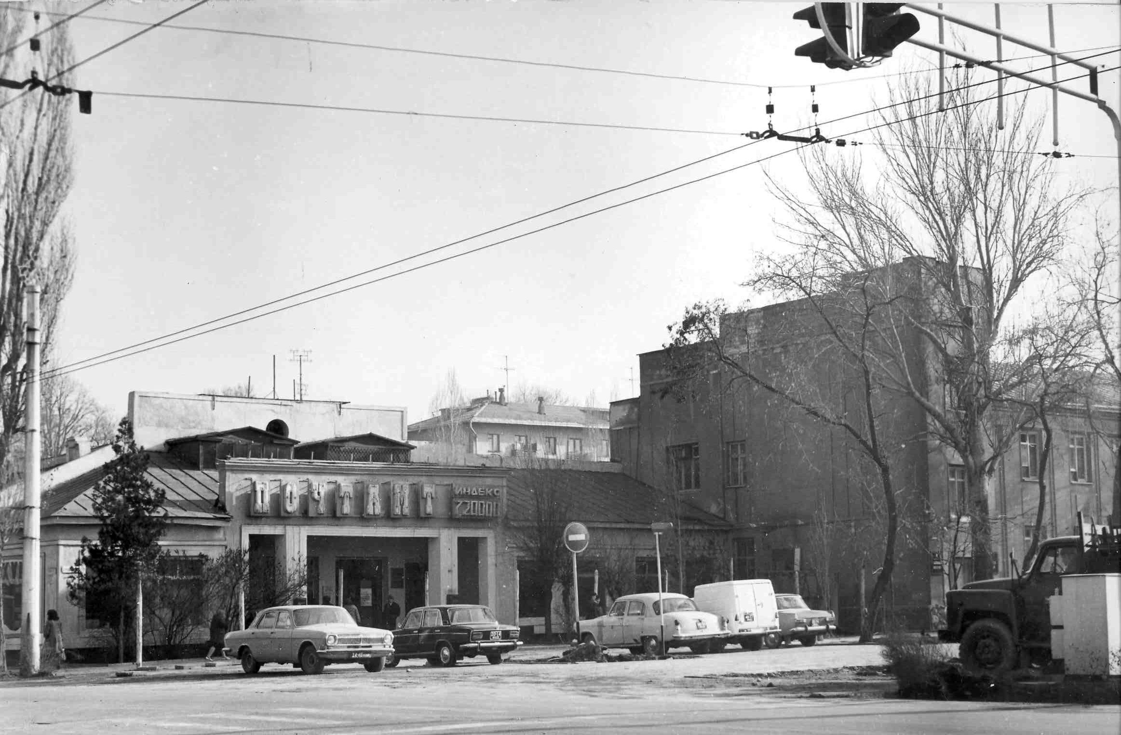
Почтамт
ENGLISH Post Office
﻿ Post Office and Ministry of Communications Building The post office building was built in 1934. Demolished during the construction of Ala-Too Square. The Ministry of Communications was formed in 1955 and was headed by the first Minister of Communications of Kyrgyzstan A. Toropkin Alexander Georgievich worked in the communications industry for 21 years, and thanks to his work, the republic’s communications reached a high level and Kyrgyzstan the
Source: https://bimap.su/description/frunze/289_Pochta.txt · BIMAP
Фотографии и материалы принадлежат их авторам; лицензия не указана

BISHKEK
No information has been found for this period yet
42.87560, 74.60487

Фотография пока не добавлена
ENGLISH
No information has been found for this period yet.

