PISHPEK
No information has been found for this period yet
42.80460, 74.57944

Фотография пока не добавлена
ENGLISH
No information has been found for this period yet.

FRUNZE
VDNKh
42.80460, 74.57944
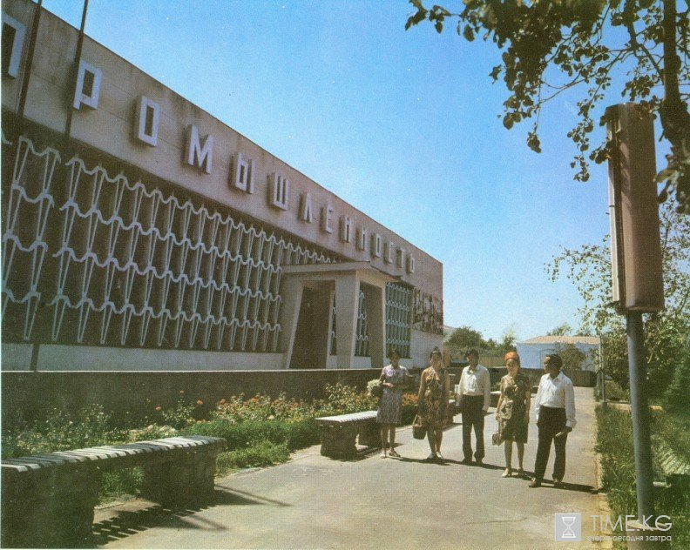
ВДНХ
ENGLISH VDNKh
﻿ VDNKh. Industry Pavilion Exhibition of achievements of the national economy of the Kirghiz SSR. Opened in 1947. Consists of 13 pavilions, an arboretum, an orchard, a zoo and 2 ponds.
Source: https://bimap.su/description/frunze/286_VDNH.txt · BIMAP
Фотографии и материалы принадлежат их авторам; лицензия не указана

BISHKEK
No information has been found for this period yet
42.80460, 74.57944

Фотография пока не добавлена
ENGLISH
No information has been found for this period yet.

