PISHPEK
No information has been found for this period yet
42.80471, 74.58120

Фотография пока не добавлена
ENGLISH
No information has been found for this period yet.

FRUNZE
Monument to Lenin at VDNKh. Photo by Viktor Glumsky
42.80471, 74.58120
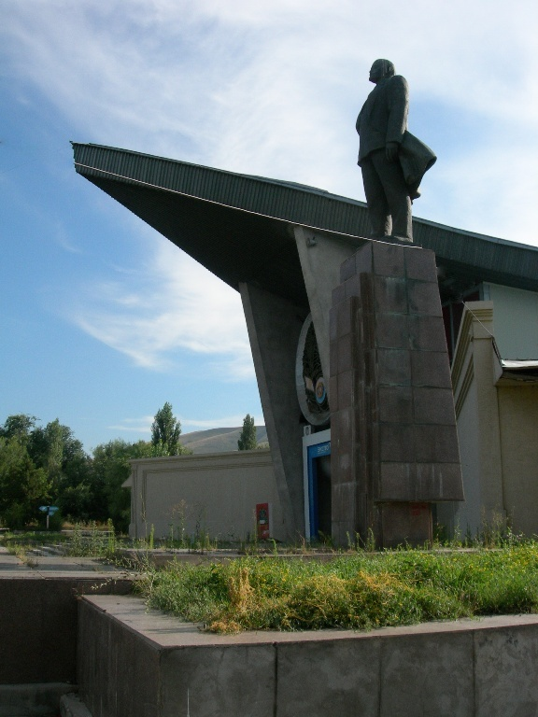
Памятник Ленину на ВДНХ. Фото Виктора Глумского · Виктора Глумского
ENGLISH Monument to Lenin at VDNKh. Photo by Viktor Glumsky
﻿ Monument to Lenin at VDNH Monument to Lenin. Installed on the central alley in 1980. Sculptor I. Rukavishnikov.
Source: https://bimap.su/description/frunze/285_Lenin.txt · BIMAP
Фотографии и материалы принадлежат их авторам; лицензия не указана

BISHKEK
No information has been found for this period yet
42.80471, 74.58120

Фотография пока не добавлена
ENGLISH
No information has been found for this period yet.

