PISHPEK
No information has been found for this period yet
42.80793, 74.58326

Фотография пока не добавлена
ENGLISH
No information has been found for this period yet.

FRUNZE
Hotel “Issyk-Kul”
42.80793, 74.58326
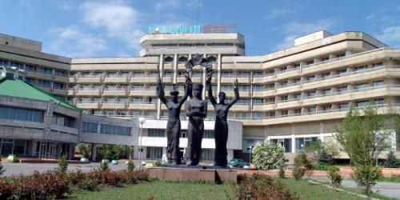
Гостиница «Иссык-Куль»
ENGLISH Hotel “Issyk-Kul”
﻿ Hotel “Issyk-Kul” Hotel “Issyk-Kul” was built in 1984 (architects K. Alykulov, K. Ibraev, M. Kerimkulov, designers G. Maliy, S. Denisov, A. Musatov). The building is eight-story, frame made of brick. On the left side of the hotel entrance there is a domed building in the shape of a yurt - it houses a restaurant and a cafe. The hotel has 185 rooms with 230 seats, a conference room with 200 seats. In 1989 The international symposium on the Great
Source: https://bimap.su/description/frunze/284_Gostiniza.txt · BIMAP
Фотографии и материалы принадлежат их авторам; лицензия не указана

BISHKEK
No information has been found for this period yet
42.80793, 74.58326

Фотография пока не добавлена
ENGLISH
No information has been found for this period yet.

