PISHPEK
On the square
42.87761, 74.60545
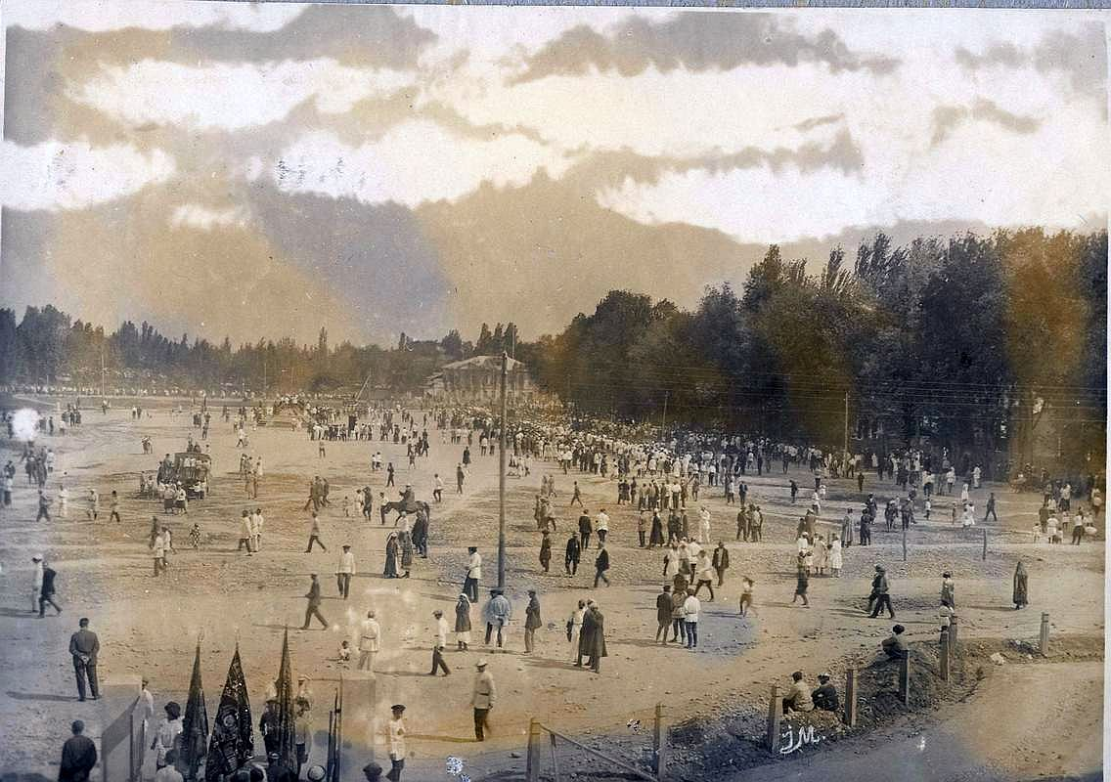
На площади
ENGLISH On the square
﻿ May 1 on Red Square 1926. In the city of Pishpek there were 5 squares: Barracks for military formations and exercises of the local team, Bazarnaya, Barachnaya and two Church squares. One of the Church Squares was located in the city center and festive festivities and parades were held there. After the 1917 revolution, it bore the name Red. The photo shows folk festivities on this square on May 1, 1926.
Source: https://bimap.su/description/pishpek/49_1Maia1926.txt · BIMAP
Фотографии и материалы принадлежат их авторам; лицензия не указана

FRUNZE
No information has been found for this period yet
42.87761, 74.60545

Фотография пока не добавлена
ENGLISH
No information has been found for this period yet.

BISHKEK
No information has been found for this period yet
42.87761, 74.60545

Фотография пока не добавлена
ENGLISH
No information has been found for this period yet.

