PISHPEK
No information has been found for this period yet
42.87904, 74.60449

Фотография пока не добавлена
ENGLISH
No information has been found for this period yet.

FRUNZE
Parade
42.87904, 74.60449
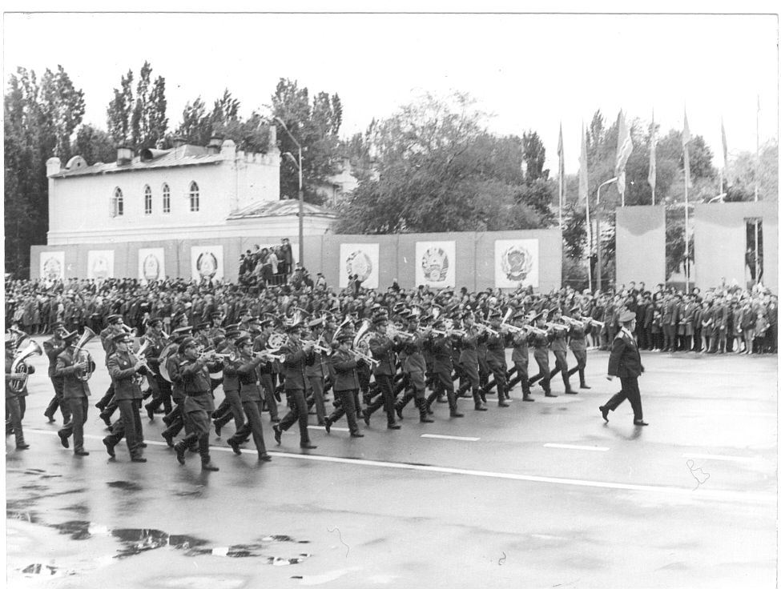
Парад
ENGLISH Parade
﻿ Parade on Government Square Parade on Government Square. Photo from 1970. On the left is the building of the Central Hotel, built according to the design of A.P. Zenkov. The building was demolished in the 60s of the twentieth century.
Source: https://bimap.su/description/frunze/281_Parad.txt · BIMAP
Фотографии и материалы принадлежат их авторам; лицензия не указана

BISHKEK
No information has been found for this period yet
42.87904, 74.60449

Фотография пока не добавлена
ENGLISH
No information has been found for this period yet.

