PISHPEK
No information has been found for this period yet
42.87467, 74.62311

Фотография пока не добавлена
ENGLISH
No information has been found for this period yet.

FRUNZE
Mosaic
42.87467, 74.62311
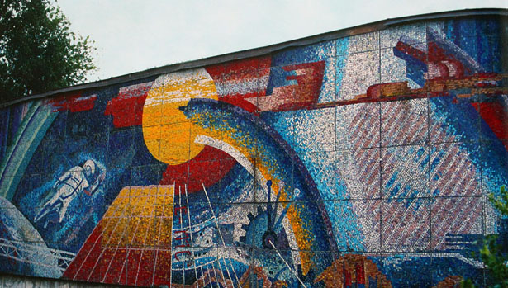
Мозаика
ENGLISH Mosaic
﻿ Mosaic “Space and scientific and technological progress” Mosaic “Space and scientific and technological progress” on the building of the House of Science and Technology. Artist M. Akmatkulov, 1984 Photo from the album “Monumental Art of Bishkek”
Source: https://bimap.su/description/frunze/277_Kosmos.txt · BIMAP
Фотографии и материалы принадлежат их авторам; лицензия не указана

BISHKEK
No information has been found for this period yet
42.87467, 74.62311

Фотография пока не добавлена
ENGLISH
No information has been found for this period yet.

