PISHPEK
No information has been found for this period yet
42.84094, 74.59528

Фотография пока не добавлена
ENGLISH
No information has been found for this period yet.

FRUNZE
Cafe "Bermet"
42.84094, 74.59528
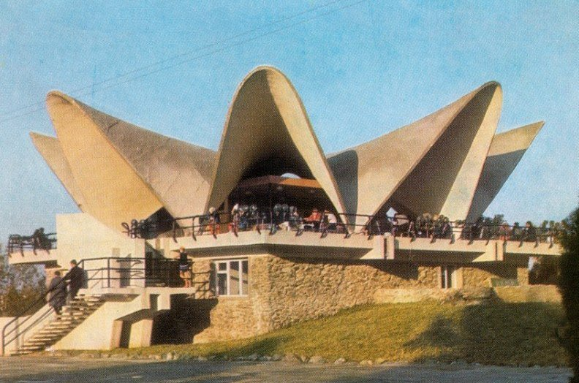
Кафе «Бермет»
ENGLISH Cafe "Bermet"
﻿ Cafe "Bermet" is located in the Park "Friendship" The park was founded in 1957 as an arboretum of the Botanical Garden of the Academy of Sciences of the Kyrgyz SSR. In 1967, the arboretum was transferred to the jurisdiction of the city executive committee as the Park of Culture and Recreation named after the 50th Anniversary of the USSR, in 1972 it was renamed the Park of Culture and Recreation “Druzhba” (now Ata-Turk Park). The central alley i
Source: https://bimap.su/description/frunze/275_Bermet.txt · BIMAP
Фотографии и материалы принадлежат их авторам; лицензия не указана

BISHKEK
No information has been found for this period yet
42.84094, 74.59528

Фотография пока не добавлена
ENGLISH
No information has been found for this period yet.

