PISHPEK
No information has been found for this period yet
42.87804, 74.60454

Фотография пока не добавлена
ENGLISH
No information has been found for this period yet.

FRUNZE
Vodkhoz
42.87804, 74.60454
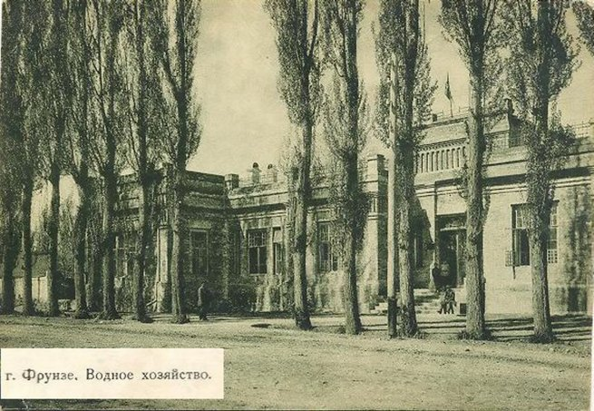
Водхоз
ENGLISH Vodkhoz
﻿ Vodkhoz The building of the Regional Vodkhoz, 1930s. It was located on the corner of Pervomaiskaya and Karl Marx streets. Irrigation College of Water Management. Photo 1934 Since 1930, the Irrigation Technical School of Water Management was located in the building of the Regional Water Resources Department, the first director of the technical school was Mamutbekov. The building was demolished during the construction of the State Historical Muse
Source: https://bimap.su/description/frunze/274_Vodhoz.txt · BIMAP
Фотографии и материалы принадлежат их авторам; лицензия не указана

BISHKEK
No information has been found for this period yet
42.87804, 74.60454

Фотография пока не добавлена
ENGLISH
No information has been found for this period yet.

