PISHPEK
Stepanenko's House
42.87927, 74.57968
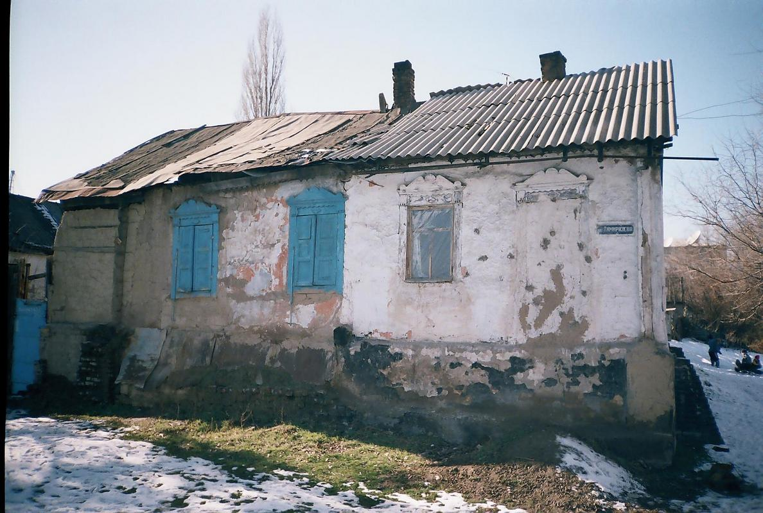
Дом Степаненко · Никиты Часова
ENGLISH Stepanenko's House
﻿ Stepanenko's House on the corner of Petrovskaya and Tatarskaya. Beginning of the 20th century This is what the old Pishpek house has become in our time, having lost its owners. It was built by settler Stepanenko, who arrived from Orsk in 1910. The road on the bulls was long and long: we left in the spring, arrived in the fall. On the way, one bull died, and they bought a camel from the Kazakhs. In Dunganovka we bought a shack on the cheap, buil
Source: https://bimap.su/description/pishpek/48_Dom_ugol_Petrovskoi.txt · BIMAP
Фотографии и материалы принадлежат их авторам; лицензия не указана

FRUNZE
No information has been found for this period yet
42.87927, 74.57968

Фотография пока не добавлена
ENGLISH
No information has been found for this period yet.

BISHKEK
No information has been found for this period yet
42.87927, 74.57968

Фотография пока не добавлена
ENGLISH
No information has been found for this period yet.

