PISHPEK
No information has been found for this period yet
42.87027, 74.59145

Фотография пока не добавлена
ENGLISH
No information has been found for this period yet.

FRUNZE
House with columns
42.87027, 74.59145
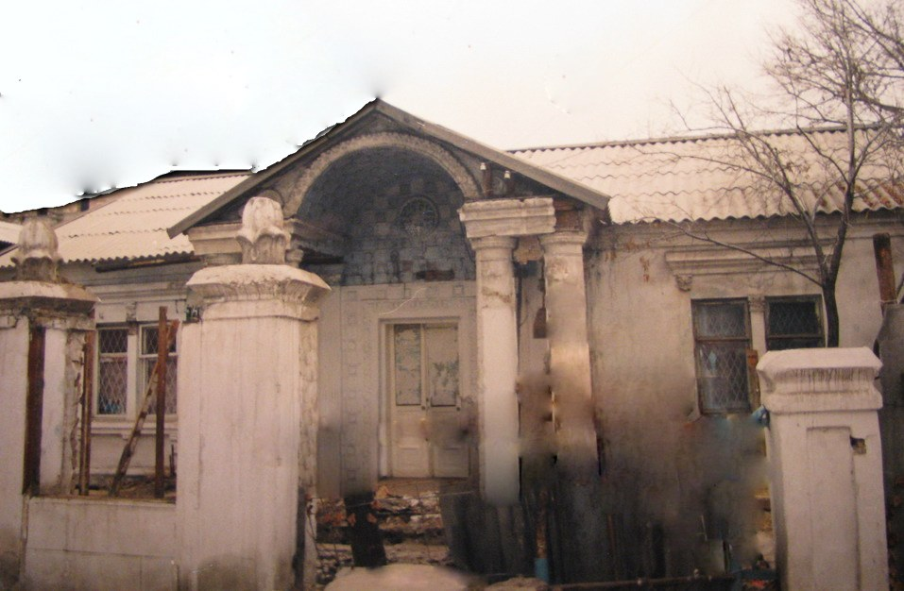
Домик с колоннами
ENGLISH House with columns
﻿ House with columns on Moskovskaya Street It was built in the 40s as the Procurement Agency for Gold Prodsnab. Until 1957, it housed the offices of Sredmetaztsvetsvetravka and Sredazzolotorazvedka, united in 1957 under the flag of Mingeo and became part of the Geology Department of the Kirghiz SSR. The house was transferred to the housing stock.
Source: https://bimap.su/description/frunze/266_Sredazzoloto.txt · BIMAP
Фотографии и материалы принадлежат их авторам; лицензия не указана

BISHKEK
No information has been found for this period yet
42.87027, 74.59145

Фотография пока не добавлена
ENGLISH
No information has been found for this period yet.

