PISHPEK
No information has been found for this period yet
42.86718, 74.60992

Фотография пока не добавлена
ENGLISH
No information has been found for this period yet.

FRUNZE
Geology Department
42.86718, 74.60992
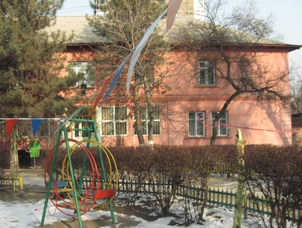
Управление геологии · Владимира Петрова
ENGLISH Geology Department
﻿ Geology Department The building of the Kyrgyz Geological Department, built in 1945. The contribution of geologists to the Victory over fascism was significant. The defense industry of the USSR received tungsten, molybdenum, mercury, antimony and lead from Kyrgyzstan.
Source: https://bimap.su/description/frunze/265_Geologia2.txt · BIMAP
Фотографии и материалы принадлежат их авторам; лицензия не указана

BISHKEK
No information has been found for this period yet
42.86718, 74.60992

Фотография пока не добавлена
ENGLISH
No information has been found for this period yet.

