PISHPEK
No information has been found for this period yet
42.86465, 74.60499

Фотография пока не добавлена
ENGLISH
No information has been found for this period yet.

FRUNZE
Geology Department
42.86465, 74.60499
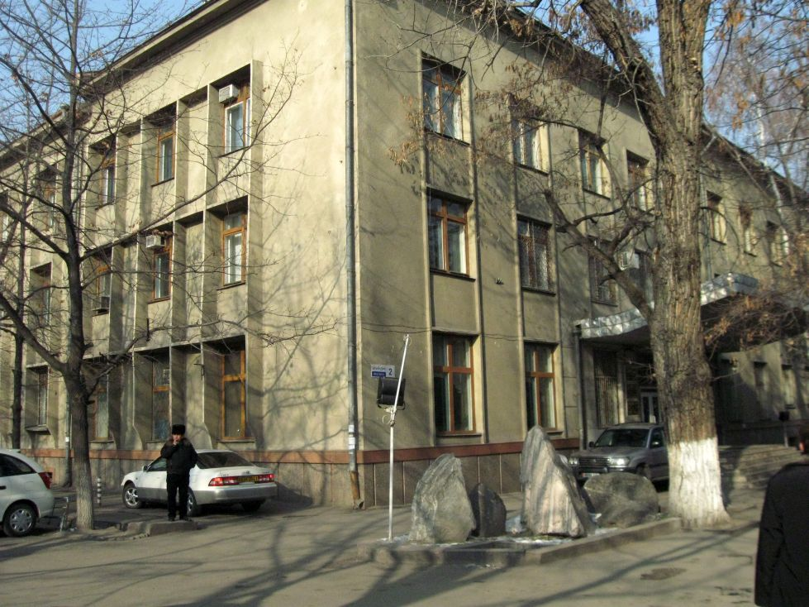
Управление геологии · Владимира Петрова
ENGLISH Geology Department
﻿ Geology Department Geology Department of the 60s. Geologists have prepared tin, tungsten, rare earth and gold deposits for industrial development. The department has a geological museum.
Source: https://bimap.su/description/frunze/262_Geologia.txt · BIMAP
Фотографии и материалы принадлежат их авторам; лицензия не указана

BISHKEK
No information has been found for this period yet
42.86465, 74.60499

Фотография пока не добавлена
ENGLISH
No information has been found for this period yet.

