PISHPEK
No information has been found for this period yet
42.83418, 74.59990

Фотография пока не добавлена
ENGLISH
No information has been found for this period yet.

FRUNZE
Embankment of the Ala-Archa River
42.83418, 74.59990
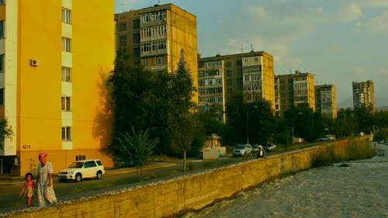
Набережная реки Ала-Арча
ENGLISH Embankment of the Ala-Archa River
﻿ Embankment of the Ala-Archa River Embankment of the Ala-Archa River. Maldybaeva street.
Source: https://bimap.su/description/frunze/260_Naberejnaia.txt · BIMAP
Фотографии и материалы принадлежат их авторам; лицензия не указана

BISHKEK
No information has been found for this period yet
42.83418, 74.59990

Фотография пока не добавлена
ENGLISH
No information has been found for this period yet.

