PISHPEK
No information has been found for this period yet
42.87916, 74.61695

Фотография пока не добавлена
ENGLISH
No information has been found for this period yet.

FRUNZE
Nakhalovka
42.87916, 74.61695
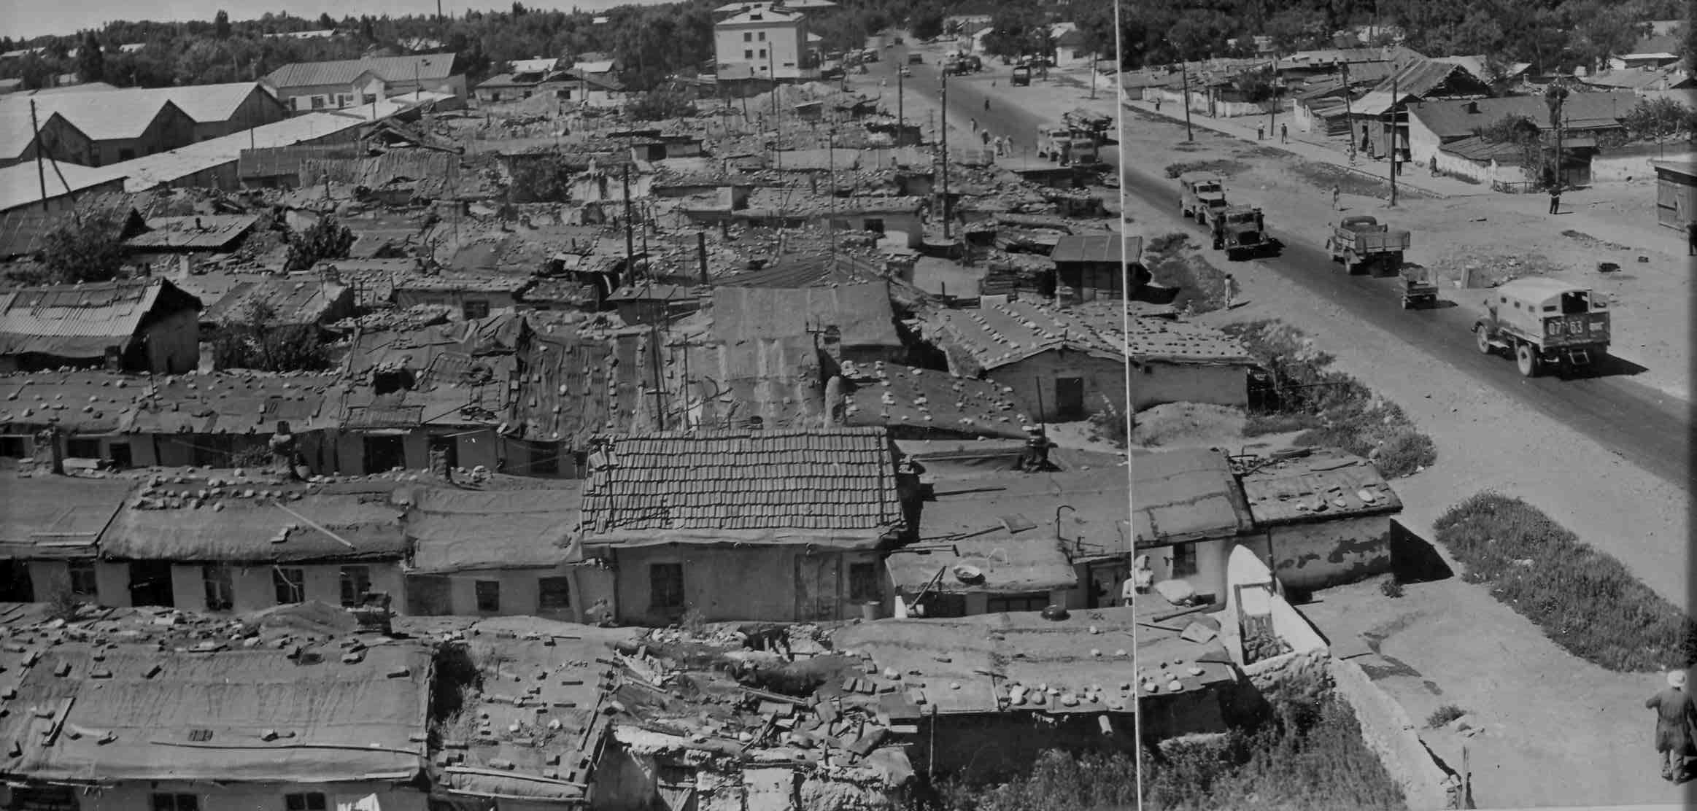
Нахаловка
ENGLISH Nakhalovka
﻿ Nakhalovka on Pravdy Street Such slums arose in city wastelands overnight and were called Nakhalovka. The homeless and the homeless settled here, building dugouts and huts. Only in the 60s did mass housing construction begin and the city was gradually freed from slums.
Source: https://bimap.su/description/frunze/258_Pravda.txt · BIMAP
Фотографии и материалы принадлежат их авторам; лицензия не указана

BISHKEK
No information has been found for this period yet
42.87916, 74.61695

Фотография пока не добавлена
ENGLISH
No information has been found for this period yet.

